

Department of Computer Science and Engineering

Lab Manual - 22CS472

DATA VISUALIZATION USING TABLEAU

Academic Year - 2024-25

Course Outcomes

|  |  |
| --- | --- |
| CO1 | Understand the basic concept of Data modelling |
| CO2 | Apply the principles of data visualization on data models |
| CO3 | Interpret exploratory data analysis for real World dataset |

Table of Contents

|  |  |  |
| --- | --- | --- |
| Experiment No | Contents of the Experiment | CO’s |
| 1 | Introduction to Tableau-  Installation, Start Page,Show Me, Connecting Excel Files, Connecting Text  Files | CO1 |
| 2 | Connecting to various data sources and preparing data:  Connecting to Tableau Server, types of connections, Preparing data for analysis, Joins, Relationships, Union, Data Blending, Aggregation in Tableau, Pivot | CO1 & CO2 |
| 3 | Working with Metadata:  Data Types, Dimensions and measures, Discreate vs continuous data, Applications, Hide-unhide and sort columns, Create Aliases | CO1 & CO2 |
| 4 | Learn Tableau Charts:  Text tables, Cross Table, highlight tables, heat maps,Bar chart, Stacked Bar chart, Line chart, Sparkline, scatter Plot,Tree Map, Bubble Chart, Word cloud | CO2 |
| 5 | Filters:  Introduction, Quick Filters, filters on dimensions, Filters on Measure, Data Source Filters , visual filters, Interactive filters, Context filters | CO2 |
| 6 | Structuring data with Tableau:Sort, Groups, Sets, Bins, Histogram, Hierarchies | CO1  &  CO2 |
| 7 | Learn Tableau Advanced : Dual Axis charts,Funnel chart, Importance of Maps, Pan Zoom and select in Tableau, Using maps to filter data, Map layering, Map search. | CO3 |
| 8 | Learn tableau Calculations: Calculated fields, Calculate Rank, Calculate Running Total, Introduction to Level of Detail(LOD), Fixed LOD, Include LOD, Exclude LOD | CO3 |
| 9. | Advanced Visual Analytics: Parameters, Parameters with filters, calculations, Column selection parameters, chart selection parameters. | CO1  &  CO3 |
| 10 | Tableau Dashboards and Story Creation: Create Dashboards, Actions in Dashboard, Dashboard Objects, Create Story | CO1, CO2  & CO3 |

Prepared by

Mahalakshmi Manasa P

GUIDELINES & INSTRUCTIONS TO STUDENTS

* Bring your college ID, class notes, lab observation book, and lab record to each lab session.
* Sign in and out of the lab register.
* Arrive on time; late arrivals exceeding 15 minutes may not be permitted.
* 100% lab attendance is mandatory.
* Adhere to the dress code.
* No food or drinks allowed.
* Leave bags in the designated area.
* Seek assistance from lab staff for any queries.
* Respect the lab and fellow students.
* Maintain a clean and tidy workspace.
* Do not use external storage devices (floppy disks, pen drives) without lab in-charge permission.

PREAMBLE

Data Visualization with Tableau

This course (choose the word that best fits your context) aims to equip you with the skills and knowledge necessary to effectively visualize data using Tableau. We will embark on a journey from understanding the fundamental principles of data visualization to mastering advanced techniques that enable you to create compelling and insightful dashboards.

Data visualization is more than just creating pretty charts. It's about transforming raw data into actionable insights, facilitating better decision-making, and communicating complex information clearly and concisely. Tableau, a powerful and intuitive tool, empowers us to achieve these goals with its drag-and-drop interface and robust analytical capabilities.

* This learning experience will cover a range of topics, including:

Data Connection and Preparation: Connecting to various data sources, cleaning and transforming data for optimal analysis.

Building Basic Charts and Graphs: Creating a variety of visualizations such as bar charts, line charts, scatter plots, maps, and more.

Interactive Dashboards and Stories: Combining visualizations into interactive dashboards and crafting compelling data stories.

Advanced Tableau Features: Exploring calculated fields, parameters, sets, groups, and other advanced functionalities.

Best Practices for Data Visualization: Understanding design principles and best practices for creating effective and impactful visualizations.

* By the end of this (course), you will be able to:

Confidently connect to and prepare data for visualization in Tableau.

Create a wide range of insightful charts and graphs.

Develop interactive dashboards and compelling data stories.

Apply data visualization best practices to communicate data effectively.

Leverage Tableau's advanced features for deeper analysis.

Whether you are a beginner with no prior experience in data visualization or a seasoned analyst looking to enhance your skills, this (series/guide/course/workshop) will provide you with the tools and knowledge you need to succeed in the exciting world of data visualization with Tableau. We encourage you to actively participate, experiment with the exercises, and explore the vast possibilities that Tableau offers

Introduction to Tableau-

Installation, Start Page,Show Me, Connecting Excel Files, Connecting Text Files

Instructions to download Tableau Public

Click on the below link to download the Tableau Public version

https://www.tableau.com/products/public/download

To download student version of Tableau Desktop

1. Click on below link

https://www.tableau.com/academic/students

2. Click on ‘Get Tableau for Free’

3. Enter your details

4. Enter your college name(DSCE) as School Name*

5. How will you be using your Tableau license?*

Select the option Learning as part of course

6. Click verify Student Status

7. Upload a picture of your College ID Card

8. The message below will be received

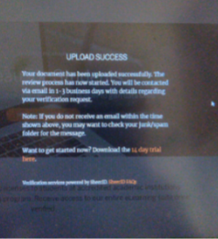

9. After verification, a mail from Tableau would be received with product key.

Step 2:

Tableau Latest Version

10. https://www.tableau.com/support/releases

11. Please install Tableau version

Tableau Latest Version

12. The file is approx. 480mb and would be downloaded.

13. Please click on the downloaded file and follow the instructions.

14. Run the exe file and enter the product key

15. Start Tableau and view the training videos

<https://www.tableau.com/learn/training/20202>

1. Find the graphical representation of category-wise sales data for the given data set of sample superstore.

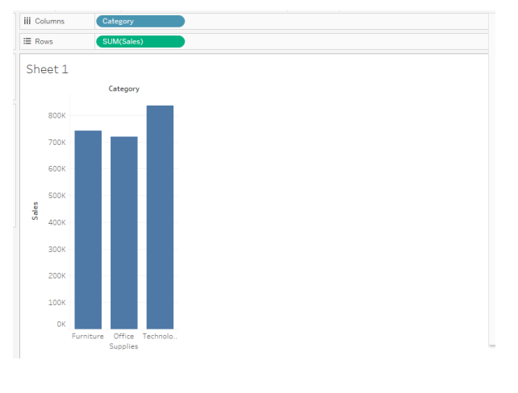

1. Find the sub-category wise Profit for the given dataset.

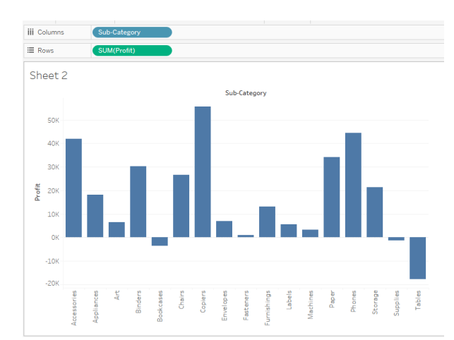

1. Explore the Profit of the category and respective sub Category, with highlighting each category in different color.

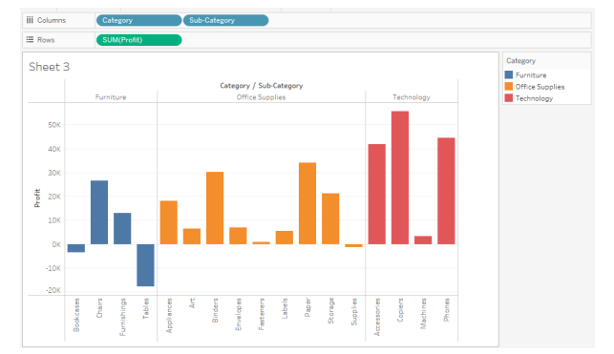

1. Explore the graphical representation of Profit and Sales of different category and sub-category.

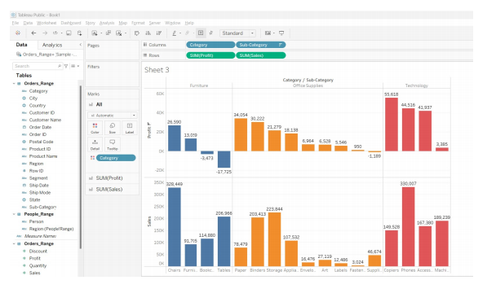

1. Find the sales according to the Order Date and Label it.

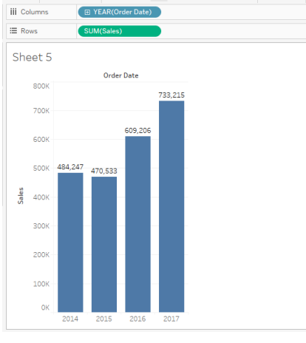

1. Find the year-wise, month-wise sales.

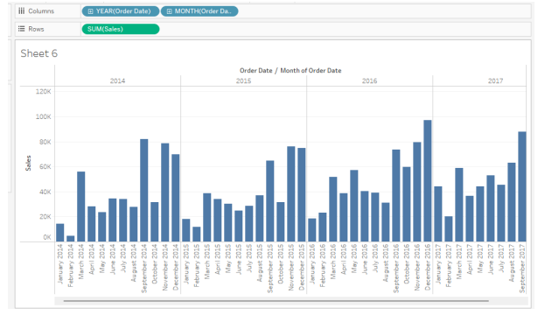

1. Analyse the sales of each product and find which product has highest sales.

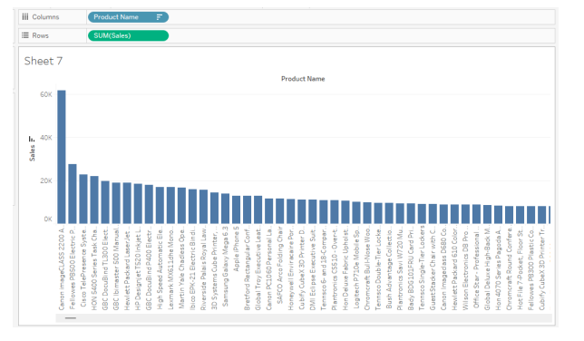

1. Find the region-wise, segment-wise sales with segments of different colors.

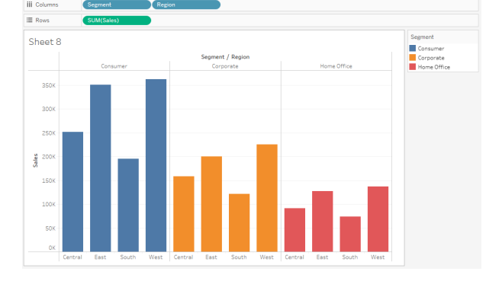

1. Find the region-wise, segment-wise sales with segments of different colors.



1. Find top 2 states with Maximum profit.

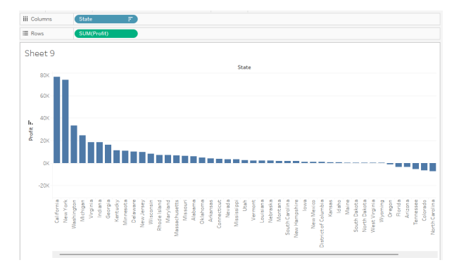

1. Analyse Region-wise , year-wise- Sales.

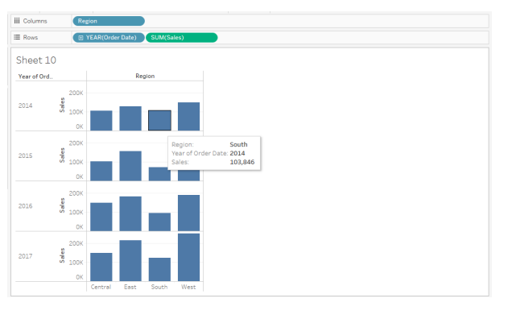

1. Which ship mode is preferred the most.

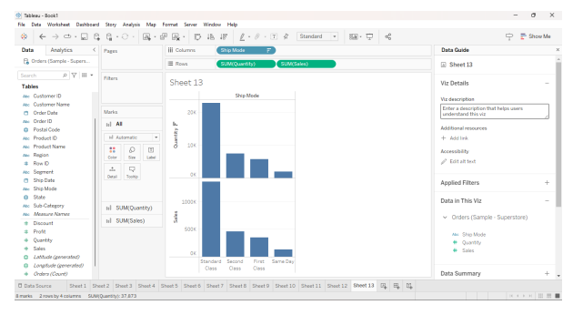

1. Get the graphical representation of profit for month-wise , year-wise , category.

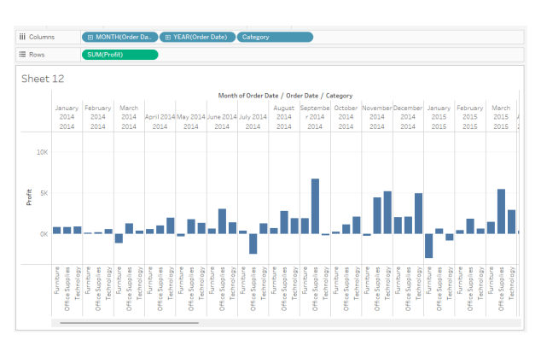

1. Find top 2 states with Maximum profit.



1. Analyse Region-wise , year-wise- Sales.



1. Which ship mode is preferred the most.



1. Get the graphical representation of profit for month-wise , year-wise , category.



Connecting to various data sources and preparing data:

Connecting to Tableau Server, types of connections, Preparing data for analysis, Joins, Relationships, Union, Data Blending, Aggregation in Tableau, Pivot

Week 2 : Visual Analytics

1. Data Blending

Data blending is a method for combining data from multiple sources. Data blending brings in additional information from a secondary data source and displays it with data from the primary data source directly in the view.

* Relationships are the default method and can be used in most instances, including across tables with different levels of detail. Relationships are flexible and adapt to the structure of the analysis on a sheet by sheet basis.   
  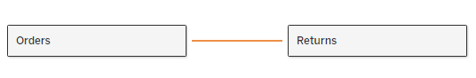
* Joins combine tables by adding more columns of data across similar row structures. This can cause data loss or duplication if tables are at different levels of detail, and joins must be established before analysis can begin.

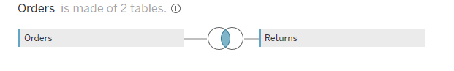

* Union, to combine two or more tables by appending values (rows) from one table to another.

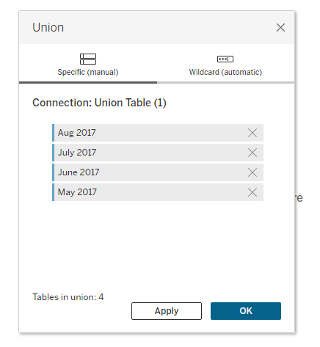

* Blends, unlike relationships or joins, never combine the data directly. Instead, blends query each data source independently, aggregate the results to the appropriate level, then present the results together visually in the view. Because of this, blends can handle different levels of detail and also work with published data sources.

1. Pivot Graphs

Pivoting data is the technique of data shaping that rotates data from a state of rows to a state of columns.

Pivot graphs are visual representations designed to summarize and analyze complex datasets, often used in conjunction with pivot tables. They are especially popular in data analysis and business intelligence tools like Microsoft Excel, Google Sheets, or similar software. Pivot graphs, or pivot charts, allow users to dynamically adjust the data being visualized by changing variables such as rows, columns, and values.

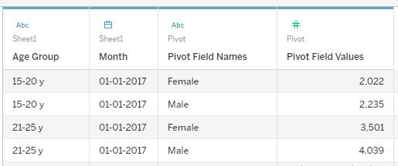

1. Aggregation

In Tableau, you can aggregate measures or dimensions, though it’s more common to aggregate measures. Whenever you add a measure to your view, an aggregation is applied to that measure by default. The type of aggregation applied varies depending on the context of the view.

1. Split

If you have string fields in your data that contain multiple distinct pieces of information (for example, the first and last name of a customer) you may be able to split the values into separate fields.

Questions:

1. How does the profit of sample superstore dataset and superstore sales dataset varies.Represent it by blending the data.

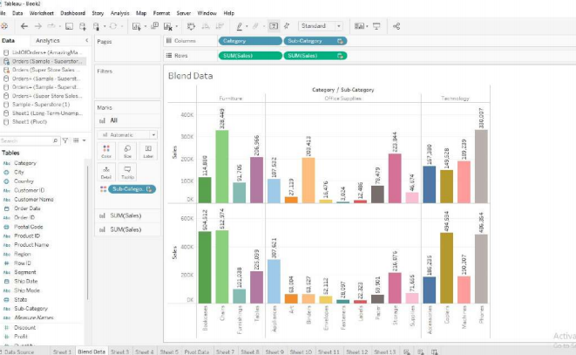

1. Create a visualization to represent the sales by segment and by individual customer

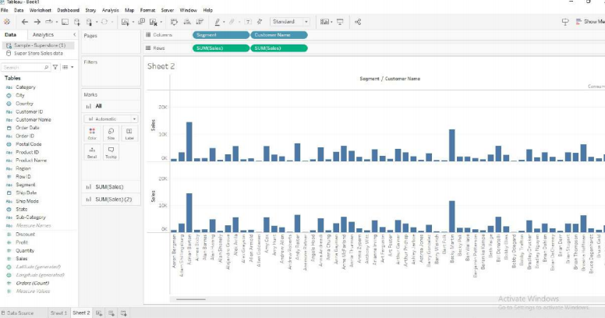

1. Represent the Sub-Category returns using the relationship between the orders and returns

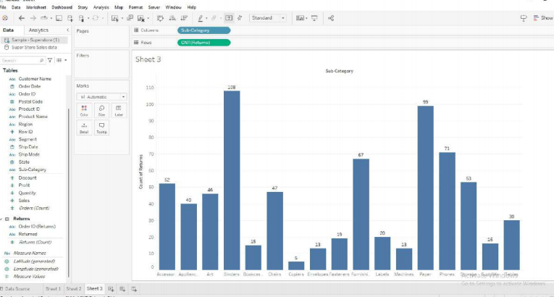

1. Find the Sub-category return according to the region making the relationship required.

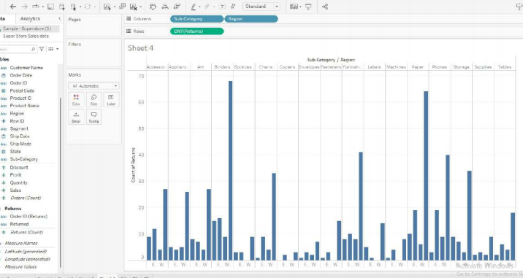

1. Joining two datasets find the Product-wise return for the sample superstore dataset.

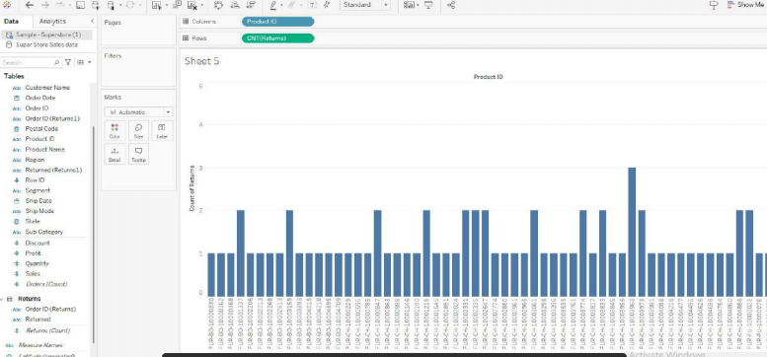

1. Using the Amazing EU2 dataset find which customer has highest sales in a region.(Join list of orders and order-breakdown)

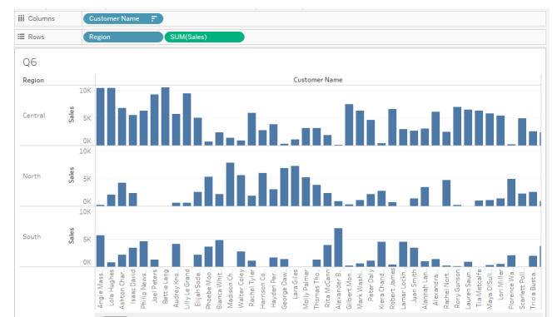

1. Using the union dataset (from dataset4 shared), Find the customer purchase for different months.

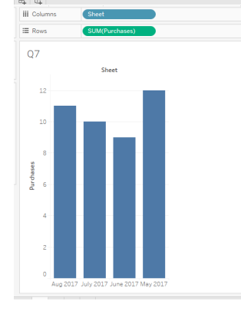

1. Create a pivot table that displays the Gender Age Ratio using the Pivot dataset shared.

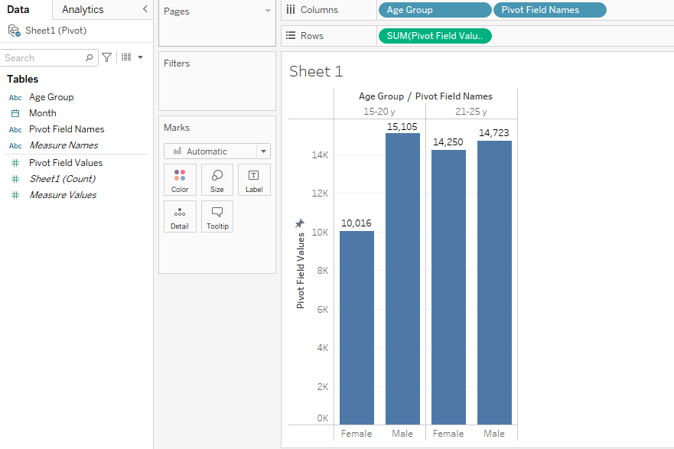

1. In the sample superstore sales dataset find the following
   1. Average Sales
   2. Median Sales.
   3. Count of Sales.

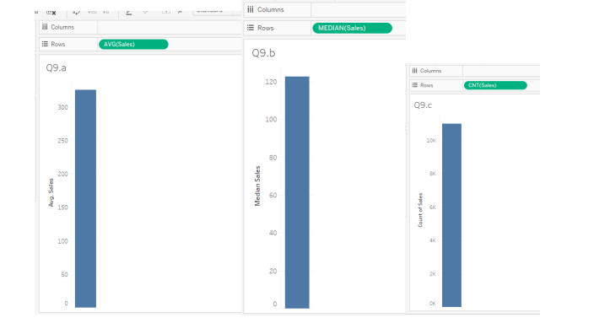

1. In sample superstore sales dataset find the return count for each country.(Join Order and return, find the country return(count))

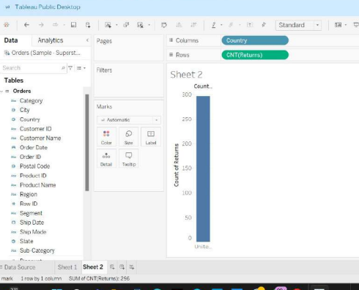

1. In the sample superstore datset Split column Name and find the region wise sales with last name.



1. Split the Order ID and for the split 3 find the regionwise sale.

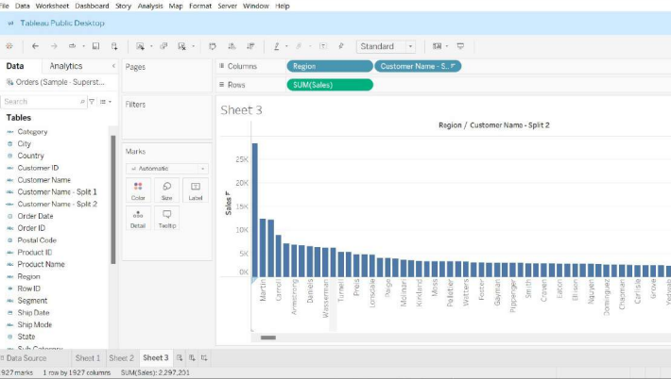

Working with Metadata:

Data Types, Dimensions and measures, Discreate vs continuous data, Applications, Hide-unhide and sort columns, Create Aliases

Week 3- Working with Metadata

Data Types

All fields in a data source have a data type. The data type reflects the kind of information stored in that field, for example integers (410), dates (1/23/2025) and strings ("Belgium"). The data type of a field is identified in the Data pane by one of the icons shown below.

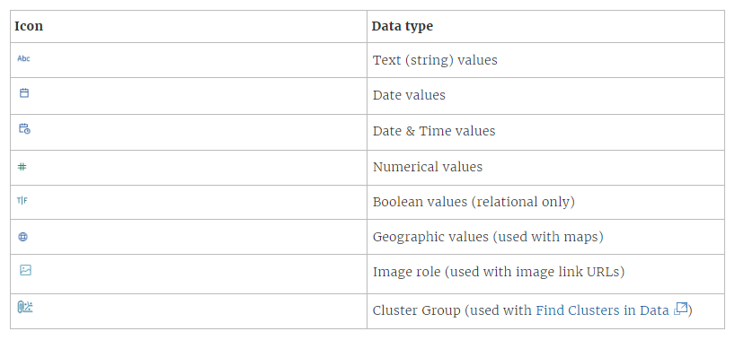

Dimensions And Measures

* *Dimensions* contain qualitative values (such as names, dates, or geographical data). You can use dimensions to categorize, segment, and reveal the details in your data. Dimensions affect the level of detail in the view.
* *Measures* contain numeric, quantitative values that you can measure. Measures are aggregated by default. When you drag a measure into the view, Tableau applies an aggregation on the pill.

Discreate And Continuous

Tableau represents data differently in the view depending on whether the field is discrete or continuous). *Continuous* and *discrete* are mathematical terms.

* *Continuous* means "forming an unbroken whole, without interruption". These fields are colored green. When a continuous field is put on the Rows or Columns shelf, an axis is created in the view.
* *Discrete* means "individually separate and distinct." These fields are colored blue. When a discrete field is put on the Rows or Columns shelf, a header is created in the view.

Q1. Find the sales for each category in the Sample superstore dataset with the exact decimal values.

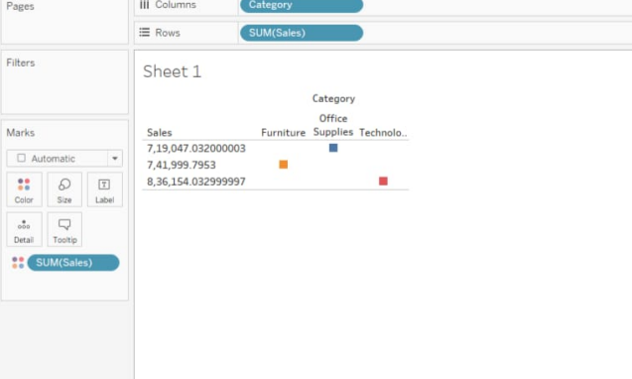

Q2. Display the Sales of each category in the Continuous value, plotting a bar graph for the same with label.

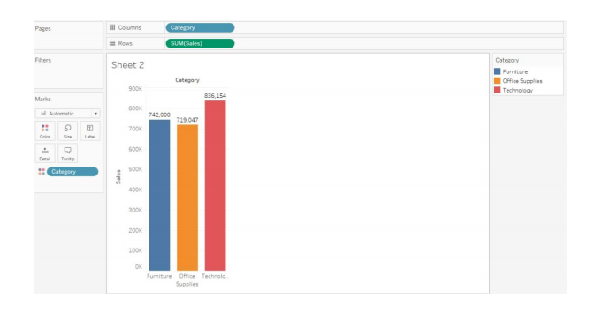

Q3. For the given data-set (Sample superstore) Change the column name ‘RowID’ to ‘ID’ and plot a Bar graph for ID belongs to what category with the sales.

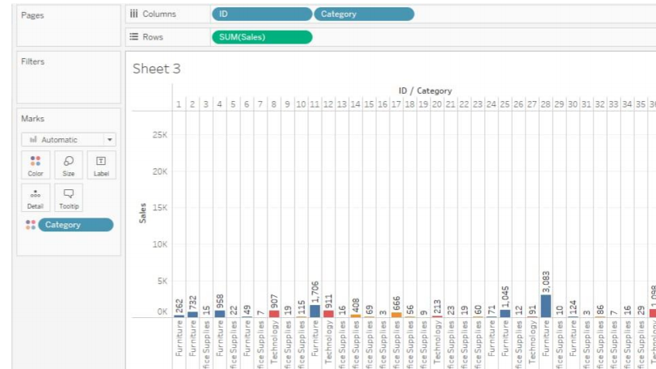

Q4. In the data-source (return table in sample superstore dataset) , Hide the column named ‘Returned’ and display the OrderID

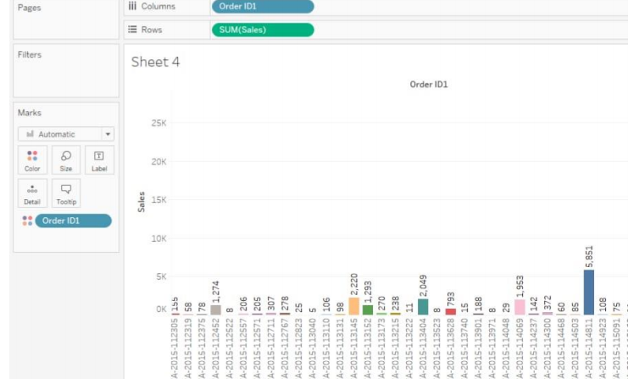

Q5. Add the comment to the field ‘Customer Name’ as “ The name of the customer is” using the sample superstore dataset.

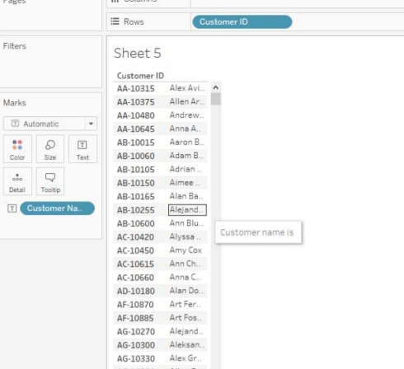

Q6. Display the labeled Category sale bar graph and Change the number format of Profit to “$’’

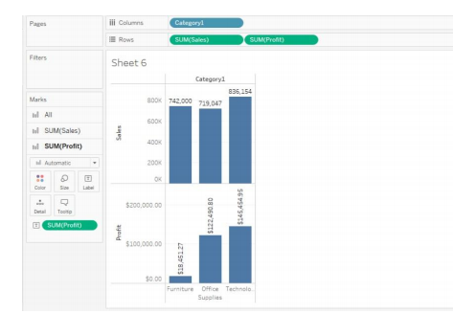

Q7. Find the category sales bar graph and label the sales in form of Indian currency in the unit of k(thousands).eg. 10000=10k.

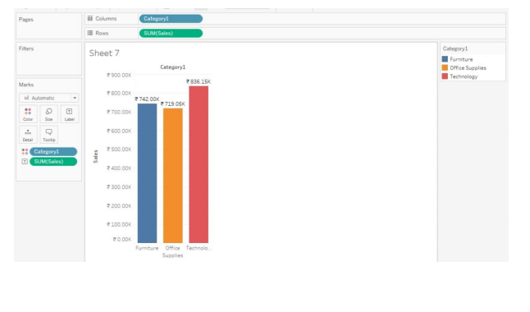

Q8. Find the average category sales using the sample-superstore dataset.

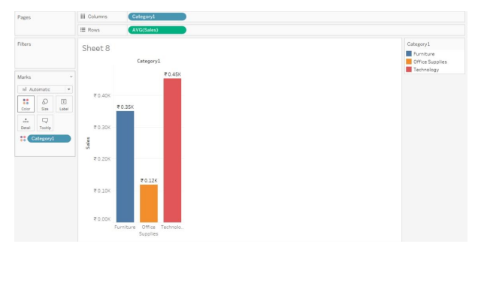

Q9. find the COUNT sales for each category using he sample superstore data-set.

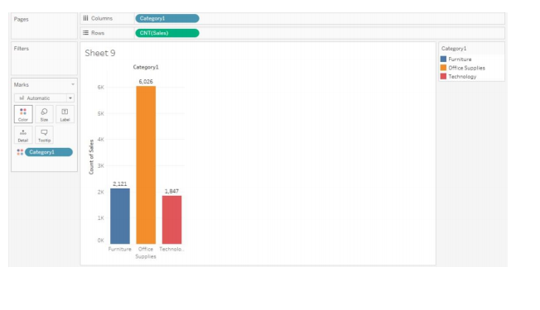

Q10.Display the sub_category sales using different shapes and color (data-set:sample superstore)

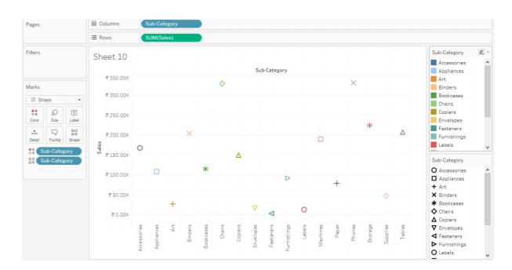

Q11. Display the Sub-category sales in the descending order of sales.

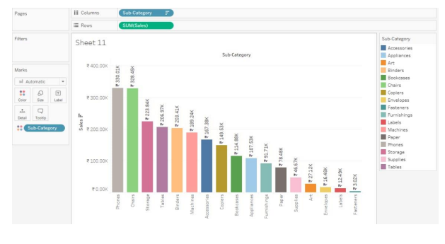

Q12. Find the sales according to the Order Date with the starting month as July of each year.(FY)

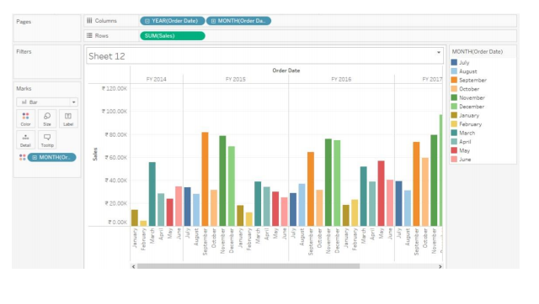

Q13. In the data source for sample superstore dateset change the name of 5 customers to their initials, like Aaron Summ as AS. And display the customer name sales bar graph.

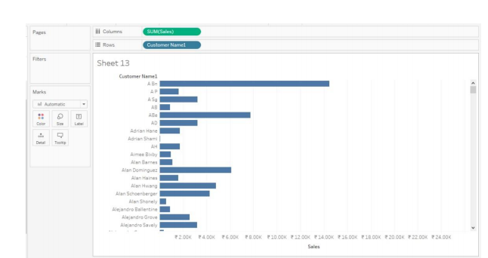

Q14. For the Airline Dataset , compare the revenue of 2 airlines on the basis of year and Region.(Join A1 and A2 on Period and region or full outer join)

Q15. Display the Year, month sales with different segment colors in the $ currency in million format

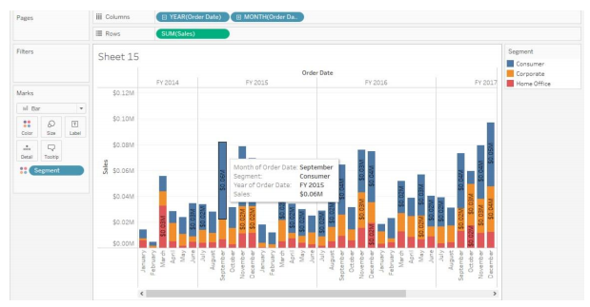.

Learn Tableau Charts:

Text tables, Cross Table, highlight tables, heat maps,Bar chart, Stacked Bar chart, Line chart, Sparkline, scatter Plot,Tree Map, Bubble Chart, Word cloud

Week 4:Tableau Charts

* A text table is a series of rows and columns that have headers and numeric values. Tableau Text table is great when the audience requires seeing the individual values.
* A crosstab chart in Tableau is also called a Text table, which shows the data in textual form. The chart is made up of one or more dimensions and one or more measures.
* Highlight tables are text tables enhanced through the use of color to show high and low values.
* A heat map is a graphical representation of data where values are depicted using colors.
* It is typically used to visualize the magnitude of values in a matrix or grid format.
* In a heat map, the intensity of colors represents the magnitude of the values being depicted.
* Bar Chart , Stacked Bar chart
* Line Graph, Sparkline Chart

Q1. An analyst at a retail company tasked with analyzing sales data across different regions and product categories. Your manager wants to see a detailed breakdown of sales performance by region and product category in a clear and concise format.

1. Connect to sample superstore dataset, including fields such as Region, Product Category, Sales Amount, and Date.
2. Create the Text Table: Drag the "Region" field to the Rows shelf and the "Product Category" field to the Columns shelf. Then, drag the "Sales Amount" field to the Text shelf. Tableau will automatically populate the text table with the sum of sales amounts for each combination of region and product category.

(You can also apply conditional formatting to highlight cells with high or low sales amounts.)

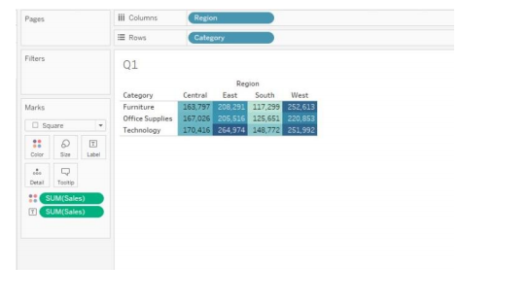

Q2. Analyze the sales performance of the Superstore across different product categories, regions, and customer segments. You want to identify the top-performing categories, regions with the highest sales, and the most profitable customer segments. (highlight )

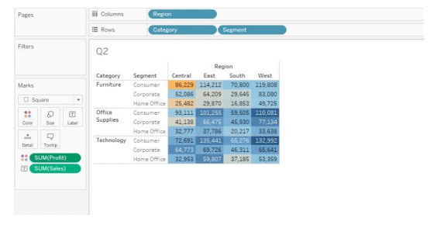

Q3. visualize the sales performance of product categories across different regions over time. You want to identify patterns such as which categories perform best in specific regions and whether there are any seasonal trends in sales.(heat map)

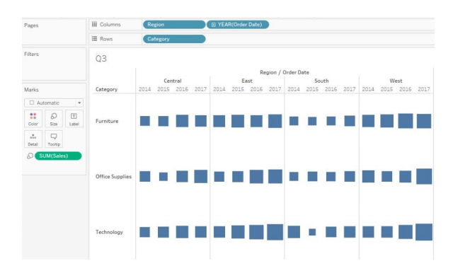

Q4. analyze the sales performance of different product categories in the Superstore dataset. You want to visualize the total sales amount for each product category to identify the top-selling categories(bar chart)

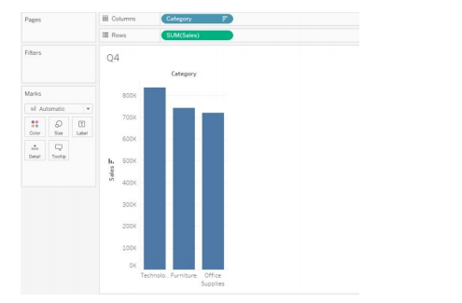

Q5. Analyze the sales performance of different regions in the Superstore dataset. You want to visualize the total sales amount for each region to identify which regions are contributing the most to overall sales. 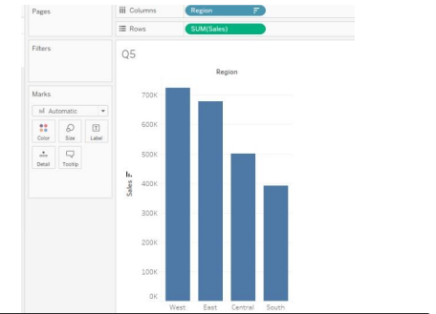

Q6. analyzing the distribution of sales across different product categories in various regions. You want to visualize how sales are distributed within each region across different product categories to identify any regional trends or patterns.(stacked bar chart)

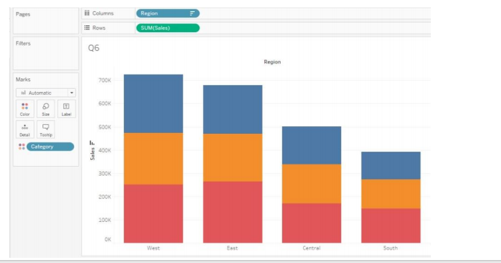

Q 7. analyze the distribution of sales across different product categories in the Superstore dataset. You want to visualize the proportion of total sales contributed by each product category to identify which categories are the most significant contributors to overall sales.

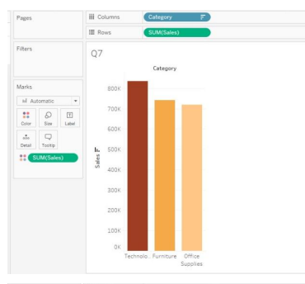

Q8.analyze the distribution of sales across different product categories in the Superstore dataset. You want to visualize the proportion of total sales contributed by each product category to identify which categories are the most significant contributors to overall sales.(Pie chart)

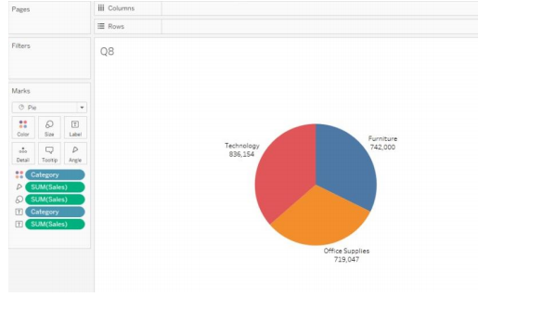

Q9. analyze the sales performance of the Superstore over time. You want to visualize how sales have evolved month by month to identify any seasonal trends or patterns in sales.(line Chart)

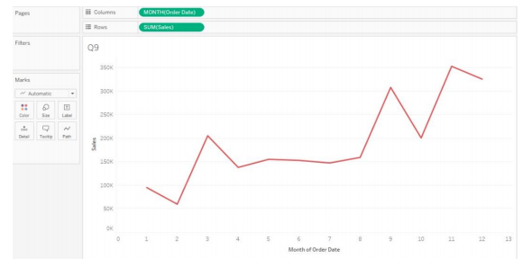

Q10. To quickly visualize the sales trend for individual product categories over time in the Superstore dataset. You want to use sparkline charts to create compact, inline visualizations within a table format to easily compare the sales trends across different categories.

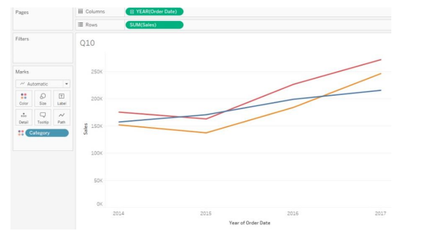

Q11. investigate the relationship between sales and profit margins across different product categories in the Superstore dataset. You want to visualize how the profit margin varies with sales for each product category to identify any correlations or patterns.(scatter plot)

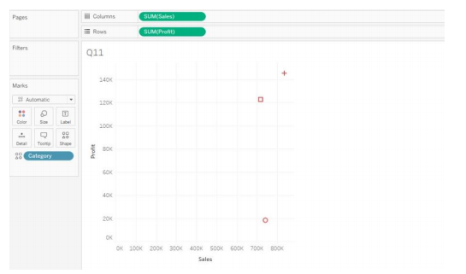

Q12. Visualize the contribution of different product categories and sub-categories to total sales in the Superstore dataset. You want to create a treemap to represent the hierarchy of product categories and sub-categories and visualize their respective sales values.

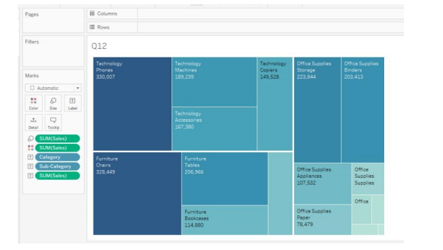

Q13. Visualize the sub category count using the word cloud.

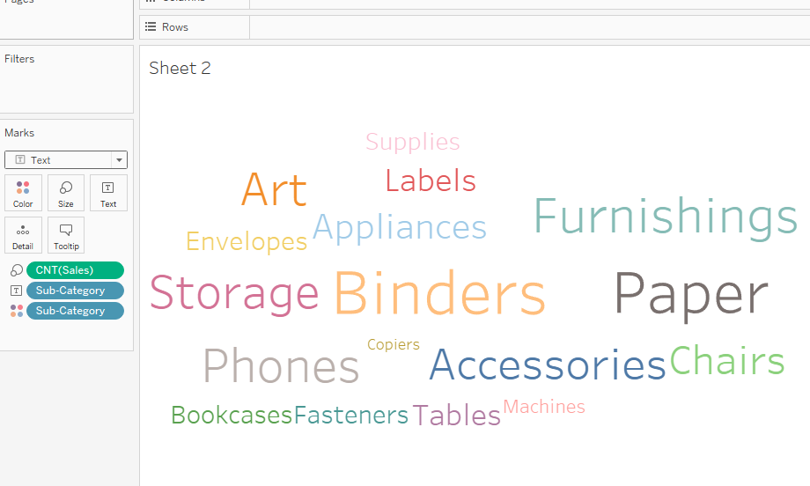

Filters:

Introduction, Quick Filters, filters on dimensions, Filters on Measure, Data Source Filters , visual filters, Interactive filters, Context filters

Week 5- Filters

Filters are cards on the worksheet that display a range of data. If the author of the workbook has included a filter card, you can include and exclude data in the view using the card.

Dimension filter

To access the values highlighted or remove them from the selected dimension, represented as strike through values

Measure Filters

In this filter, you can apply the various operations like Sum, Avg, Median, Standard Deviation, and other aggregate functions. In the next stage, you would be presented with four choices: Range, At least, At most, and Special for your values.

Quick Filter:

Quick Filters provide a swift and accessible means to implement various filter types in Tableau. By simply right-clicking on a field, users can efficiently access different filtering options. It helps you to quickly access different filter types in Tableau through the right-click option. It owns features required to fulfill all typical filtering needs. You can implement Quick filters in Tableau on measures or dimensions.

The Data Source Filter:

The data source filter in tableau helps in the direct application of the filter environment to the source data and quickly uploads data that qualifies the scenario into the tableau workbook.To execute such processes, you need to go to the Data Source tab and select the Add option in the upper right corner.

Q1. Using Quick filters find the following

1. Sub-Category “accessories” Sales in the “central” Region.

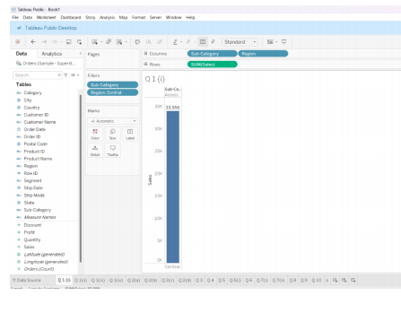

1. Sub-category sales in “west” Region.

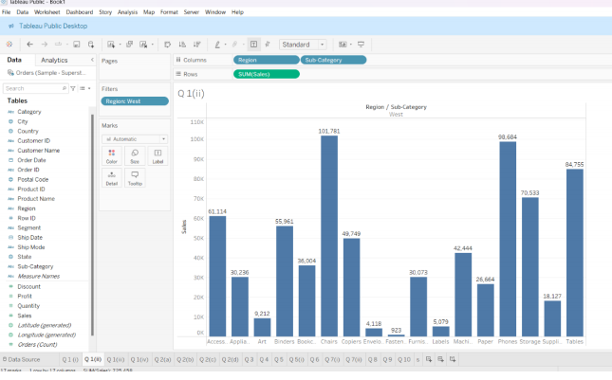

1. Which sub-category has highest sales in the ‘East” Region.(sort)

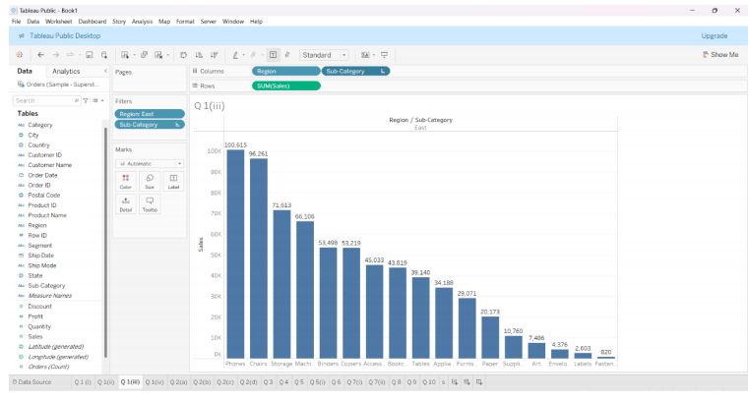

1. Using the multiple value list compare the sub-category sales in the “East and West “region.

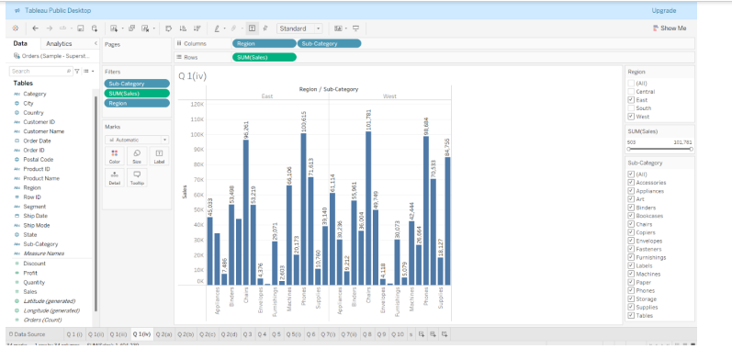

Q2. Using the Dimension filters find

1. Sub-category “ chairs,art,label,paper ,phones,machines,tables” sales.

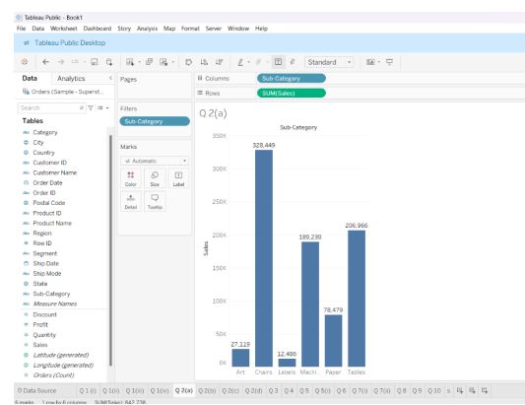

1. The sales of all the sub-category starting from the letter “a”

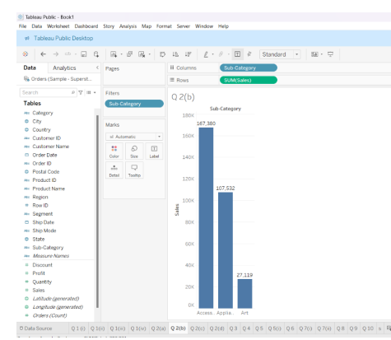

1. The sales that is greater then ‘200,000’.

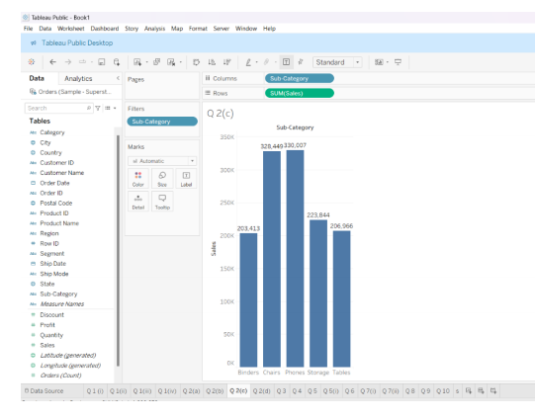

1. Find the top five sub-category sales.

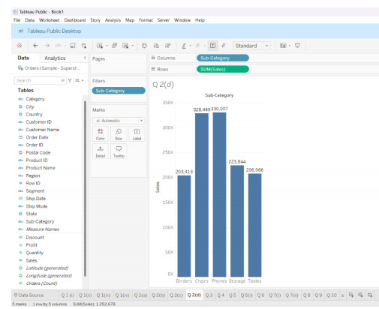

Q3. Find the sub category sales in the Q3,Q4 of ship date.

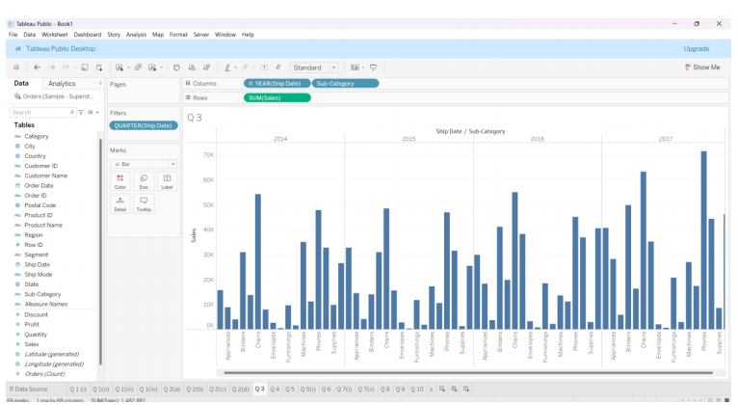

Q4. Find the sub-category sales in the order year 2016,2017.

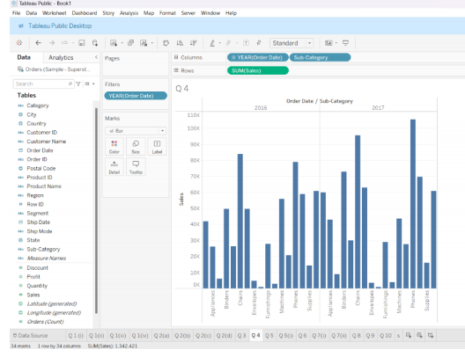

Q5 Find the category, sub-category profit for all the years. Also display the profit for 2016,2017(using the quick filters).

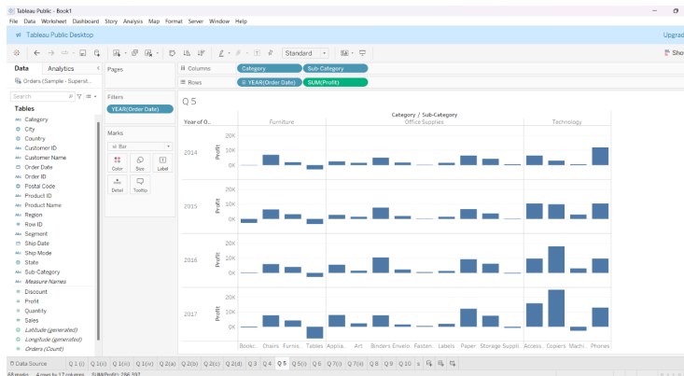

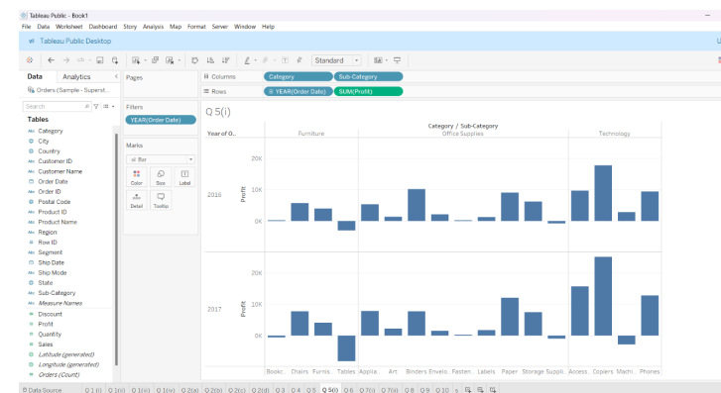

Q6. Find the category , sub-category Profit for the month of March of all years.

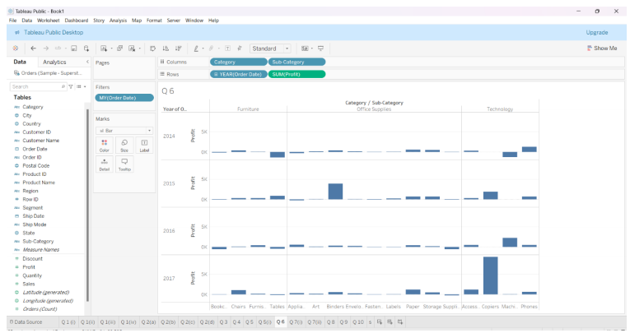

Q7. Using the measure filter find the following:

1. Sub-category sales for the sales(sum) ranging from 10000 to 500000.

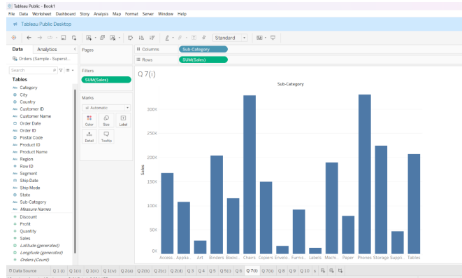

1. Category, sub-category Profit for sales(sum) ranging from 10000 to 500000

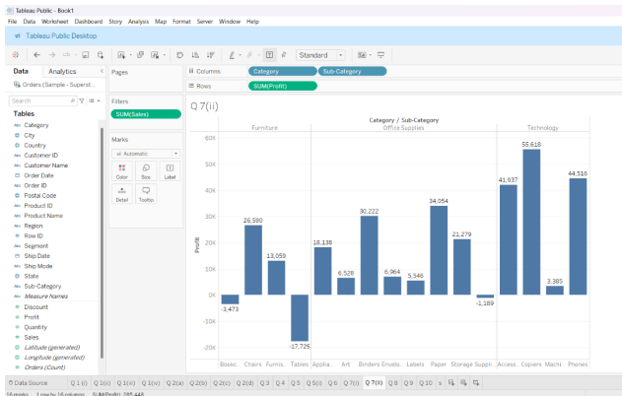

Q8. Find the top 5 states with the maximum profit.

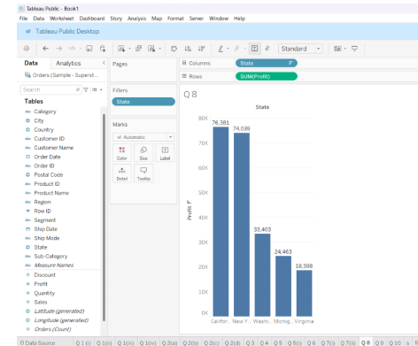

Q9. Find the sub-category profit where the name of sub-category starts from”p” and the sales(sum) is greater than 100000.

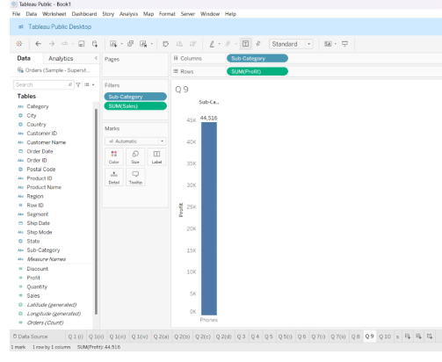

Q 10. Find the category, sub-category sales for April month of all years.

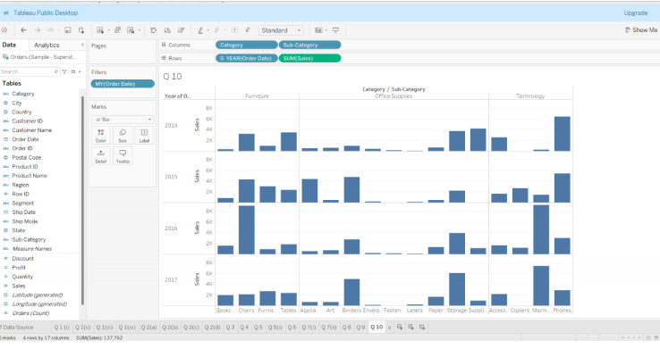

Q11. Apply the data source filters with the sub-category starting with “a” and year is 2016 and 2017. Find the category , sub-category sales.

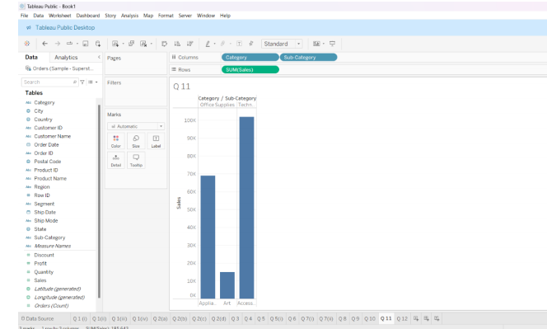

Q12. Apply the filter on Data Source with the order year is 2015,2016 and get the Category, sub-category sales.

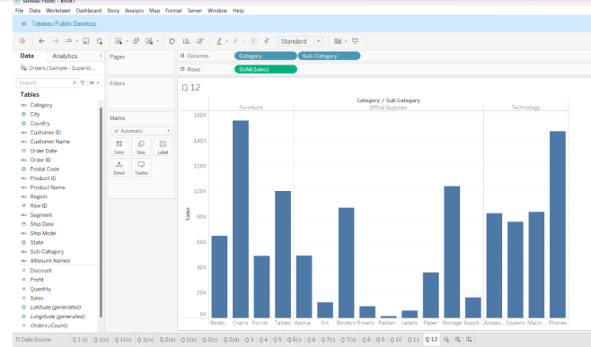

Q13. Explain Context filters with an example.

Structuring data with Tableau:

Sort, Groups, Sets, Bins, Histogram, Hierarchies

Week 6- Sort, Groups, Sets, Bins, Histogram, Hierarchies

Tableau uses the current International Components for Unicode (ICU) library to determine sort order. You can customize sorting by using the Sort menu for specific fields. (The Sort menu is not available for continuous measures.)

1. Right-click (Windows) or control-click (Mac) the field you want to sort, and select Sort.
2. Select a Sort By option, and configure its behavior:

Data Source Order sorts based on how the data is sorted in the data source.

Alphabetic sorts the data alphabetically. This sort is case sensitive, sorts [A-Z] before [a-z], and treats digits individually (that is, 19 comes before 2).

Field lets you specify the field value used to determine the sort order. The field doesn’t need to be used in the visualization. You can also select an aggregation for the sorting field. The aggregation options available depend on the field type.

Manual lets you select a value and move it to the desired position, either by dragging it in the list or using the arrows to the right.

Nested lets you select the field value used to determine the sort order. The field doesn’t need to be used in the visualization. You can also select an aggregation for the sorting field. The aggregation options available depend on the field type.

## Group

Groups in Tableau allow users to organize and combine values under a single label. This can be done for both dimension or measure values. To create a group to combine related members in a field.

In the view, select one or more data points and then, on the tooltip that appears, click the group icon .

(*refer: <https://help.tableau.com/current/pro/desktop/en-us/sortgroup_groups_creating.htm)>

## Create Sets

## sets are custom fields that define a subset of data based on user-defined conditions. They can be used to make data more meaningful and useful in dynamic ways

## Sets are custom fields that define a subset of data based on some conditions.

(*Refer: <https://help.tableau.com/current/pro/desktop/en-us/sortgroup_sets_create.htm)>

## Bins

## Bins in Tableau are containers of equal size that organize data into categories or ranges for analysis and visualization. They can be used to create visualizations like histograms, bar charts, and heat maps. Bins can be useful for working with continuous data, such as prices, quantities, and ages.

(* refer : <https://help.tableau.com/current/pro/desktop/en-us/calculations_bins.htm> )

## Hierarchies

 The Hierarchy in Tableau is an arrangement where the entities are presented at various levels.

(* refer: <https://help.tableau.com/current/pro/desktop/en-us/qs_hierarchies.htm> )

Question:

1. For the sub-category sales in SampleSuperstore dataset, sort the sub-category in the descending order of datasource.
2. For the category ,sub-category sales in SampleSuperstore dataset, sort the sub-category in the ascending aphabetical order.
3. Sort the sub-category in ascending order of profit for the subcategory sales in sample superstore dataset
4. Using the manual sort , sort the sub-category sales where the “phones and paper” are arranged on the top
5. Using the nested sort, sort the sub-category sales in the descending order of sales.
6. Create two groups of subcategory , group 1 contains the sub-category starting with “a to m” and remaining in group 2. Display the yearly sub-category sales for both the groups.

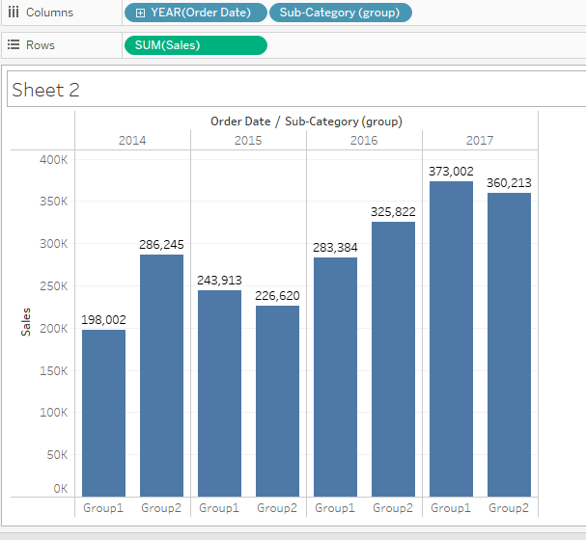

1. For the sales profit graph for sub-category, create two groups with 7 items in one group and remaining in other , show the graph using
   * + - 1. “Include other”
         2. Without using “include others”

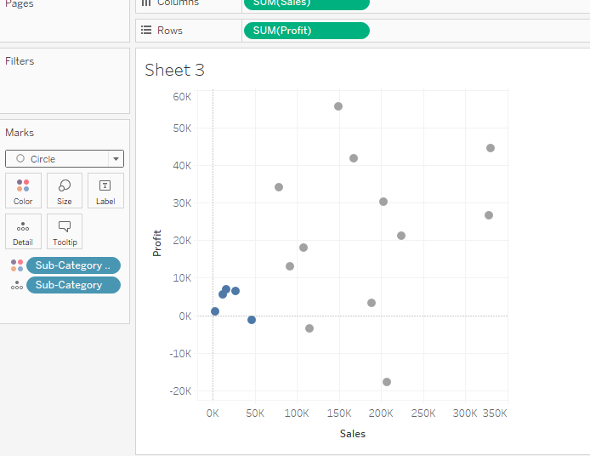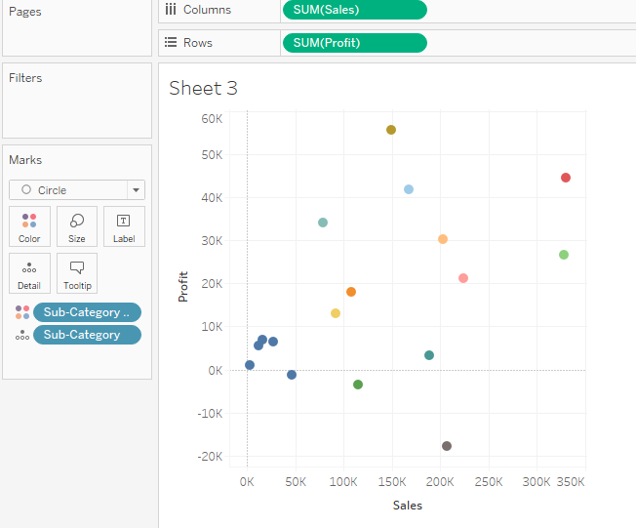

1. Create the set for sub-category with top 10 sales data. Display the set sales.

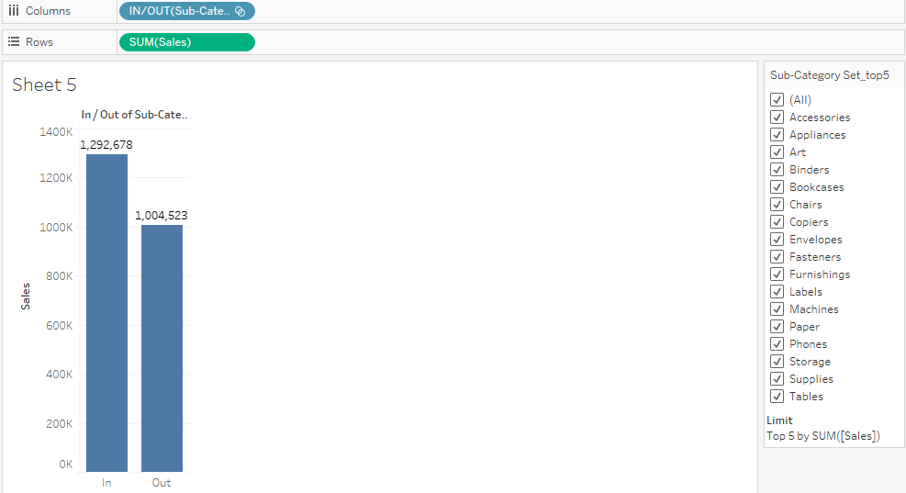

1. Create the combined set of top 5 sub-category sum(sales )and top 5 sub-category sum(profit) and display the sales of shared members in both sets.

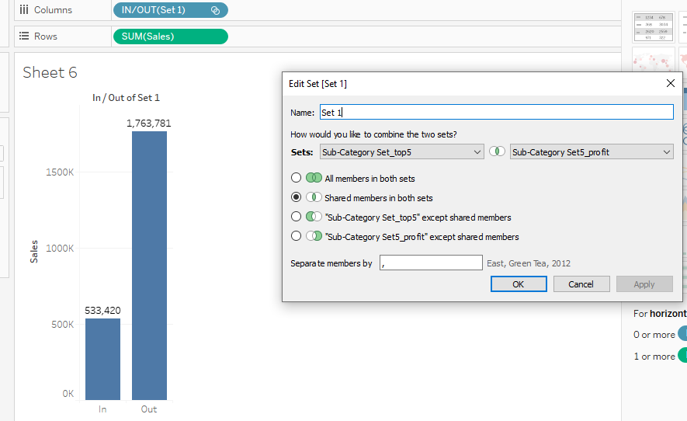

1. For the bin size of 100 units, display the sub-category sales

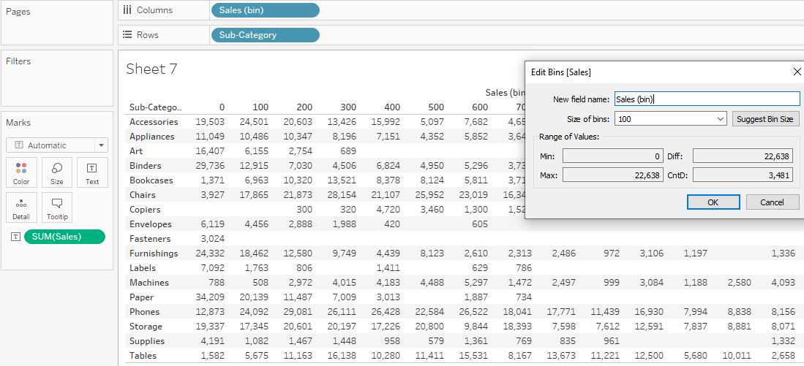

1. For the bin size of 100 units create the subcategory sales (bin)with the sales count.

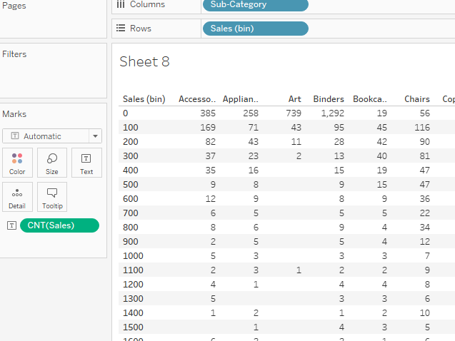

1. Create the Product hierarchy including the Product Id, Product name, Category and sub-category.

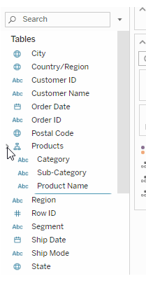

1. Create the product hierarchy and display the Sub-category measure values.

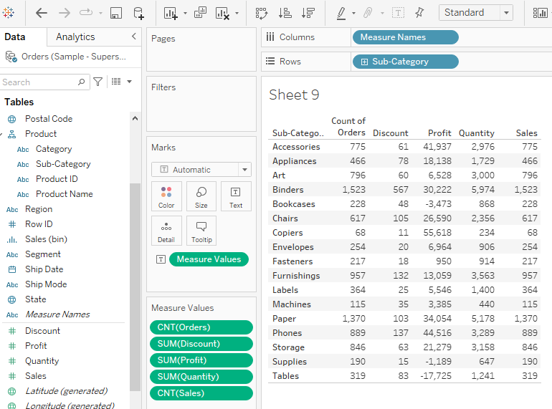

1. Create the combined set as” customer Name” including all the members data of set one as the top 5 sales and another set with the top 5 profit .

Learn Tableau Advanced : Dual Axis charts,Funnel chart, Importance of Maps, Pan Zoom and select in Tableau, Using maps to filter data, Map layering, Map search.

Week 7 : Learn Tableau Advanced

Dual Axis charts

A dual-axis chart is used to present the relationship between two variables. More specifically, these charts are useful for demonstrating the relationship between two or more measures with different amplitude and scale.

Q1.Create the sales vs profit Ratio dual axis chart.

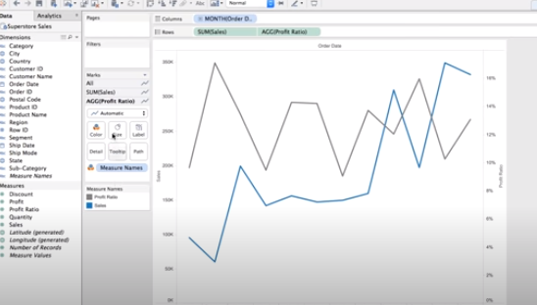 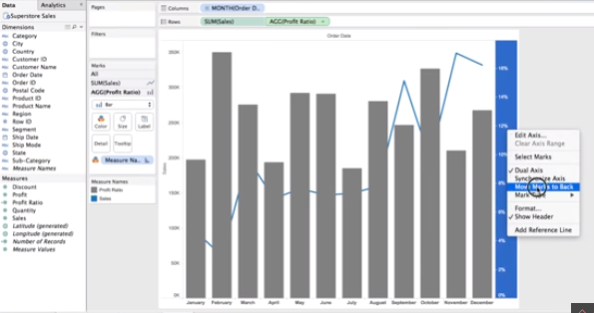

Q2. Create the dual axis lollipop charts for sub-category sales.

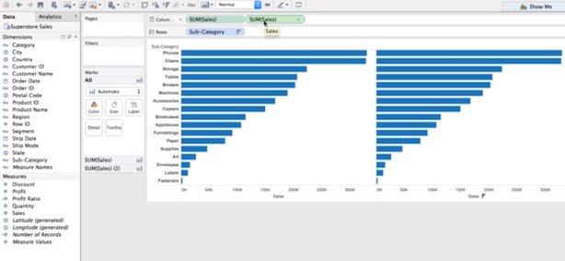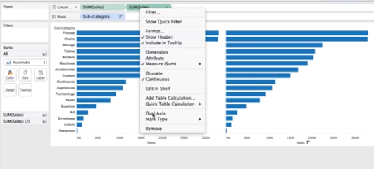

Q2. For the given dataset, create the funnel chart

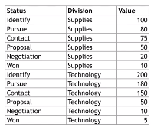

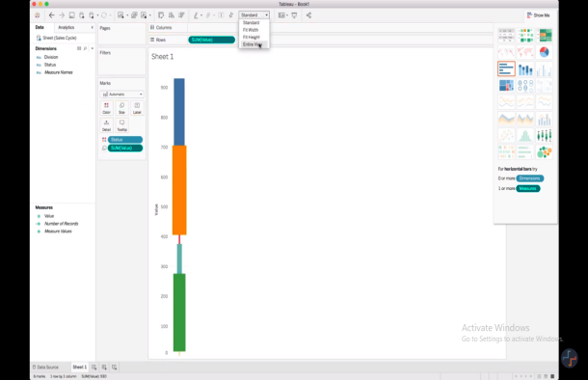

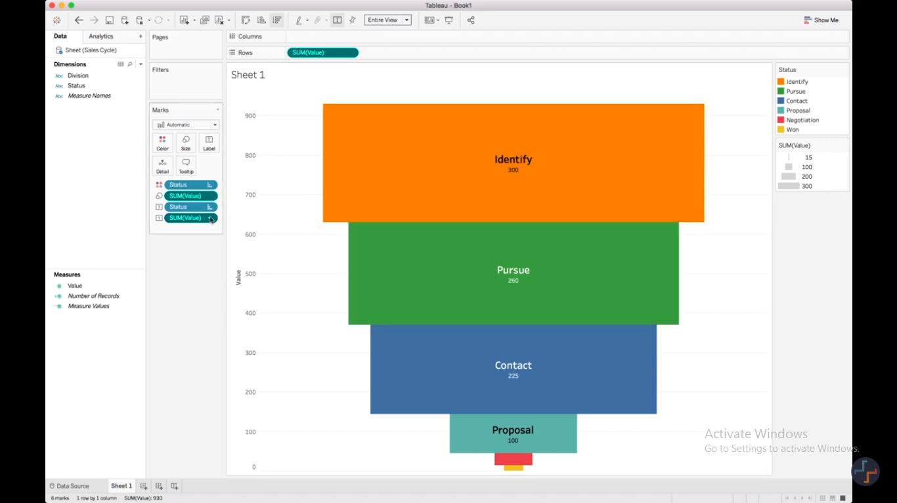

Q3. Analyse the state sales using the map chart.

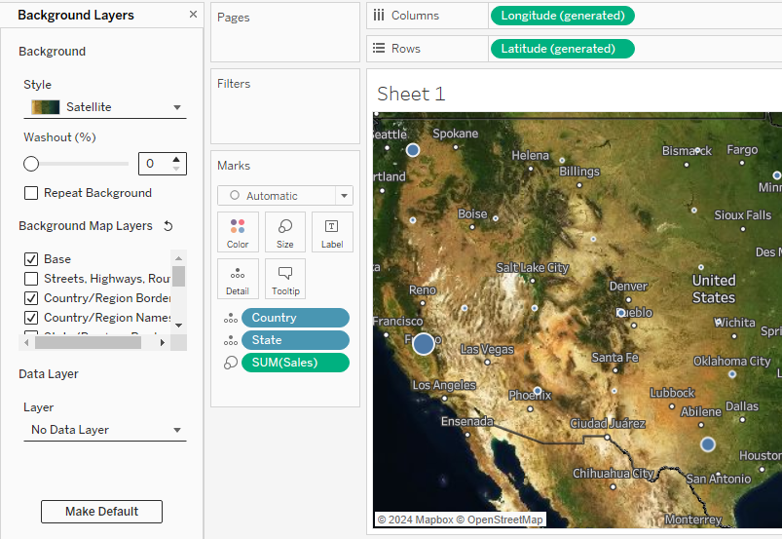

Learn tableau Calculations: Calculated fields, Calculate Rank, Calculate Running Total, Introduction to Level of Detail(LOD), Fixed LOD, Include LOD, Exclude LOD

Week 8: Calculative Fields

Tableau Calculations

Q1. Find the number of days taken to between the order date and shipping date?

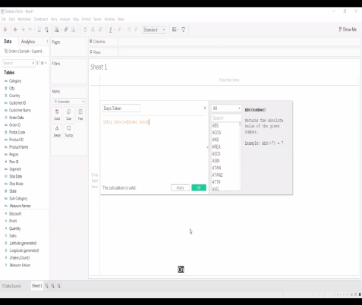 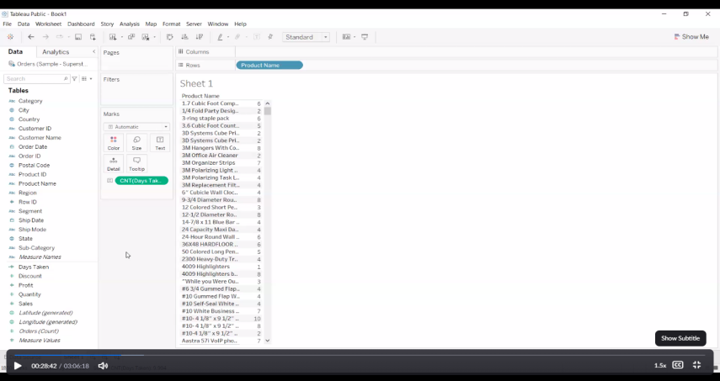

Q2. Find the sub-category wise profit Ratio

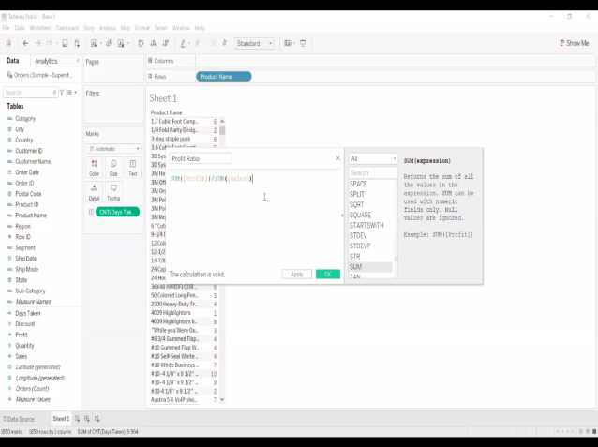 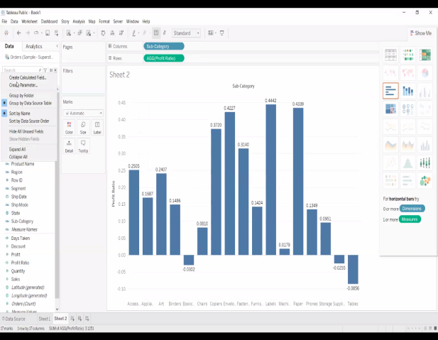

Q3. A)Find the negative sales for the category , sub -category.

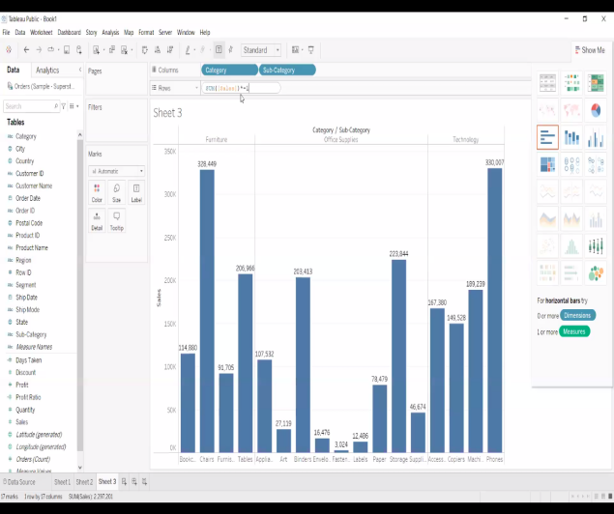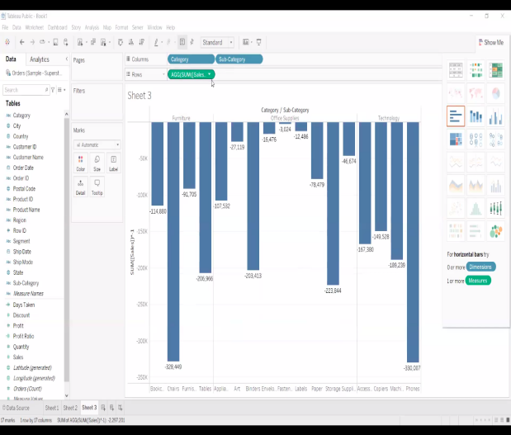

B.) IncreaseIncrese All the sales by 1000.

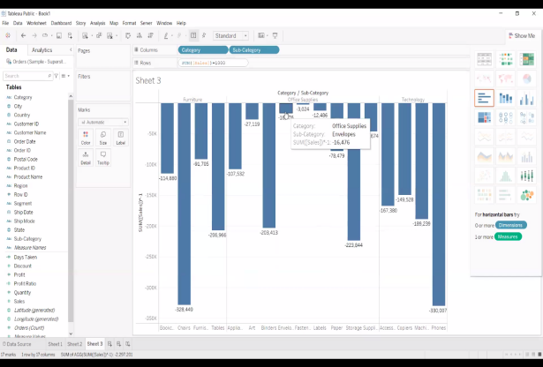 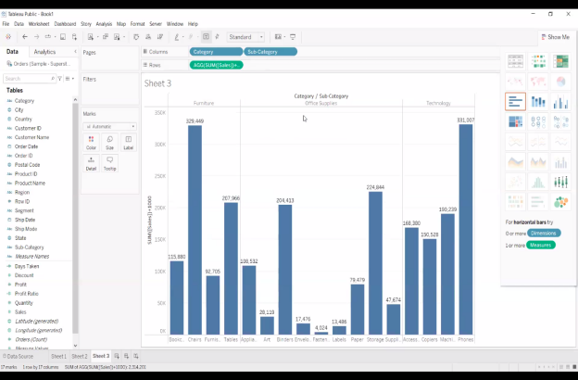

Quick table Calculations:

Q4.

1. Find the running total(1,2,3,4,…==> 1+2,1+2+3,1+2+3+4….) for the sub-category sales:

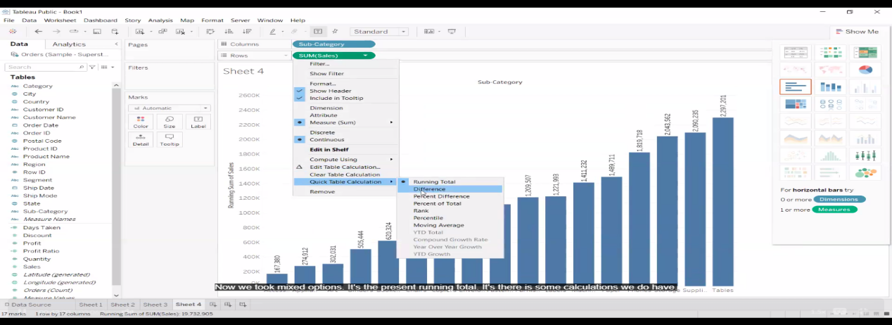

1. Find the percentage total of sub-category sales using quick calculations.

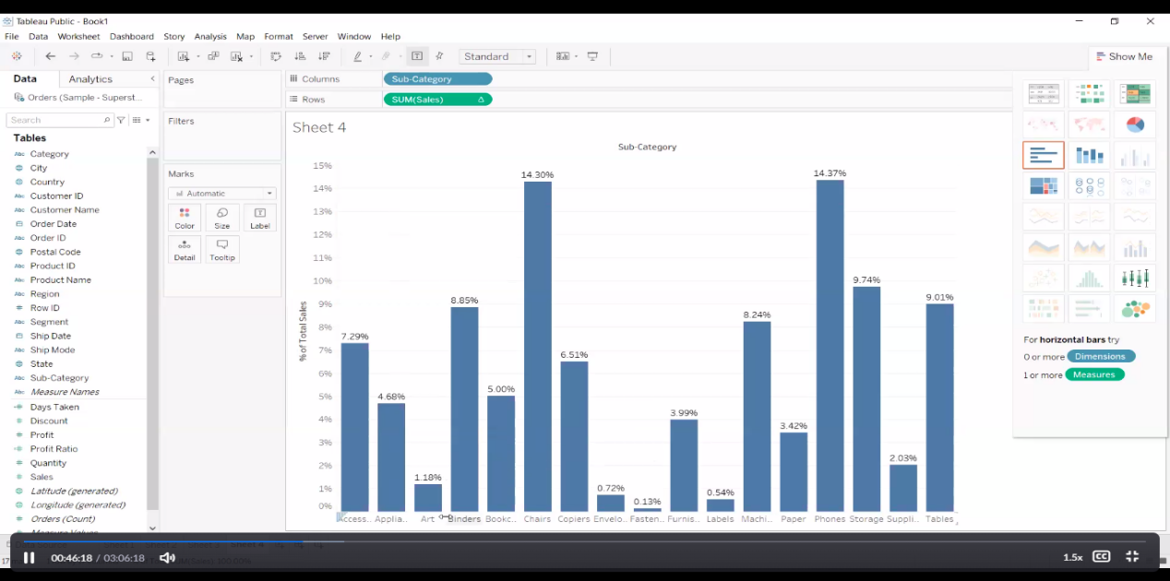

1. Find the Rank for the sub-cat sales according to the ascending and descending order using edit table calculations

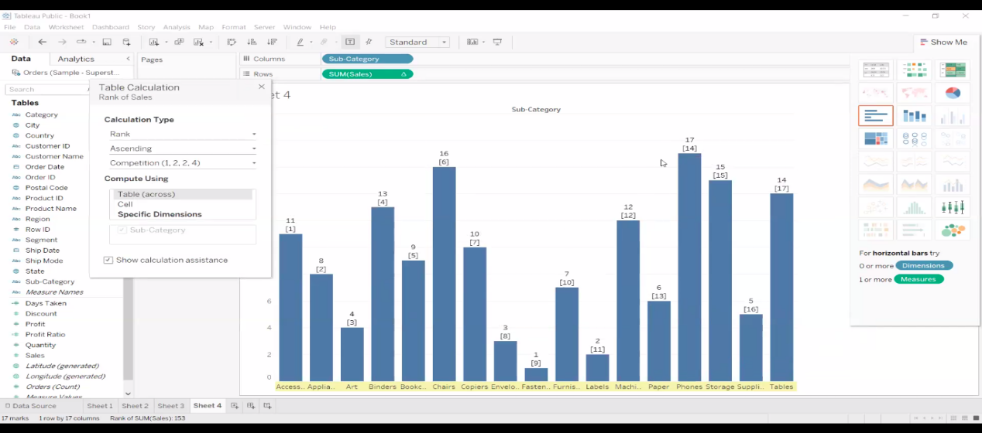

1. Find the percentile, moving average for the year,sub-cat sales

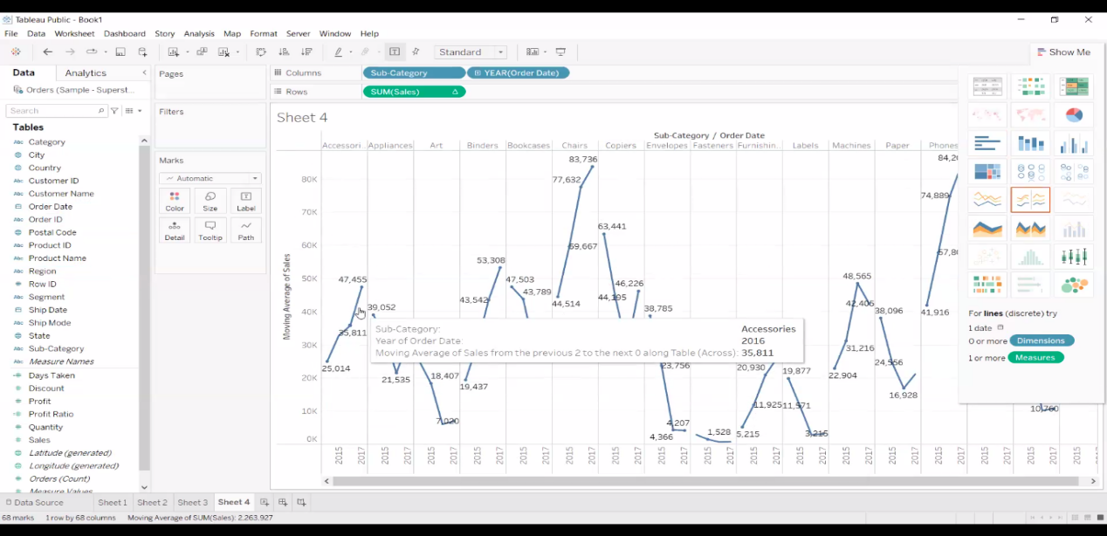

Q5. Find the waterfall chart for the sub-category profit

- create the sub-cat profit bar chart

- get the running total of profit(quick calculations)

-Marks: Gantt chart

- Marks: drag profit to size

-marks: profit (double click)- Profit*-1

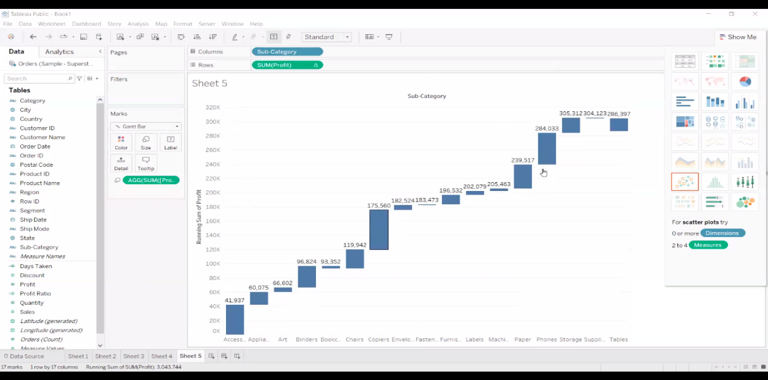

Level of Detail Calculations

1.)Fixed

2.)Include

3.)Exclude

Q6. Find the first order date (launch date) of each product

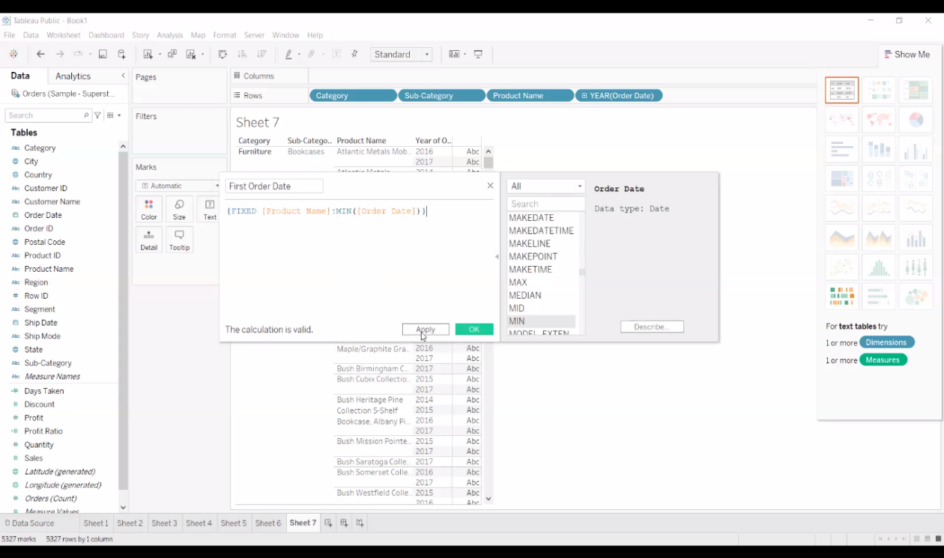

Drag first order date to label.

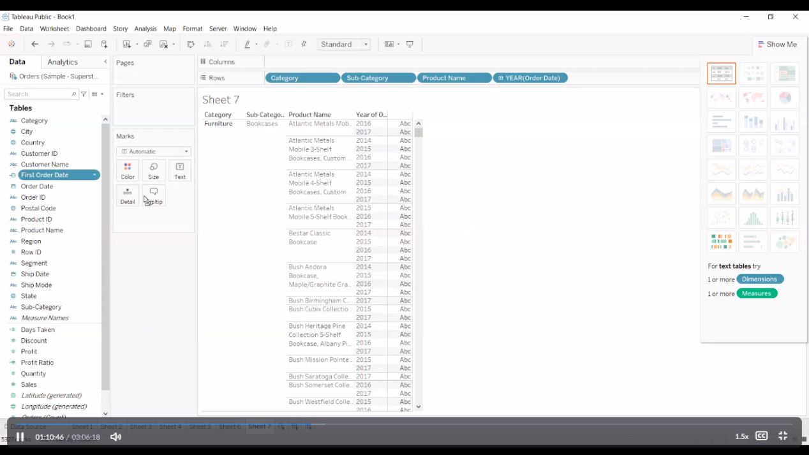

Q7.

- find the sub-cat average sales

- write the cal fields

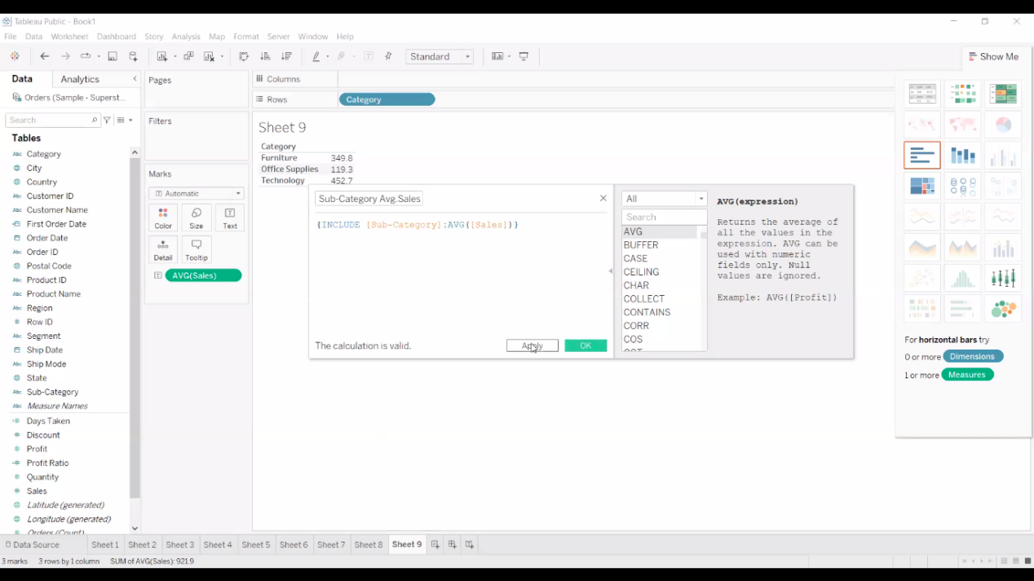

-double click on new generated field

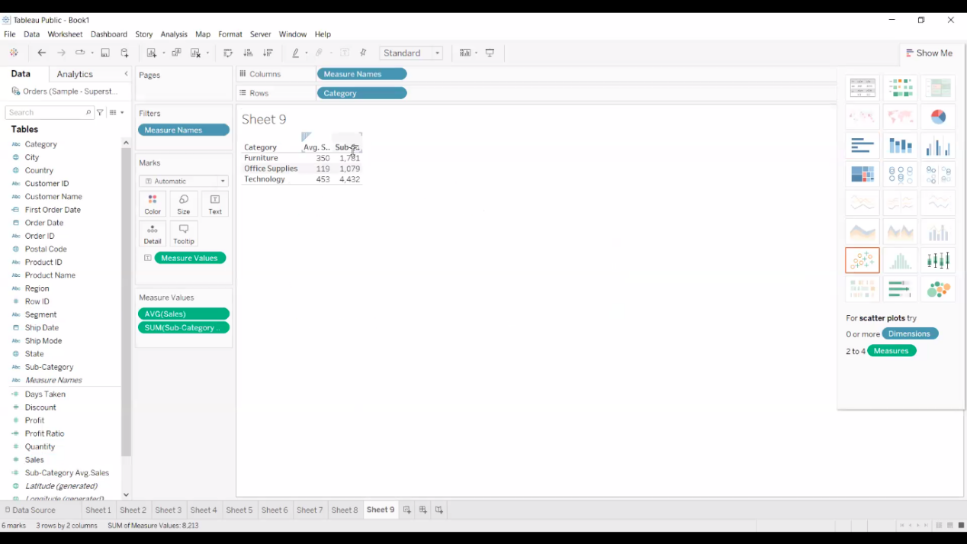

Q 8. use the Exclude level of detail for category , sub-category sales.

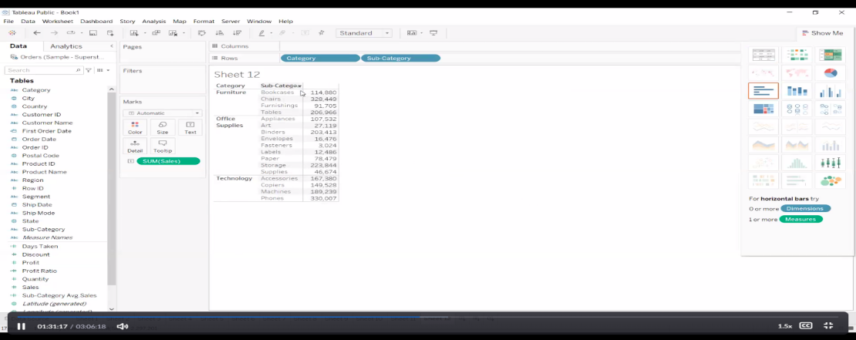

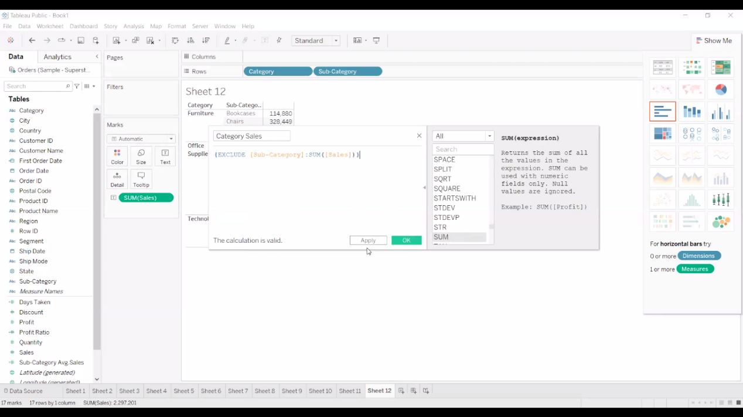

https://absentdata.com/level-of-detail-calculations/

Advanced Visual Analytics: Parameters, Parameters with filters, calculations, Column selection parameters, chart selection parameters.

Week 9 : Parameters

Create dimension parameter:

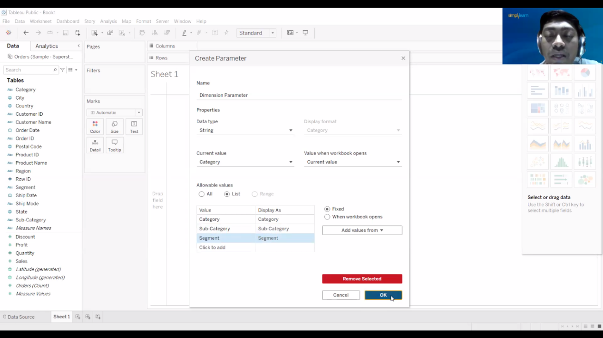

Using Dimension Parameter create calculative field:

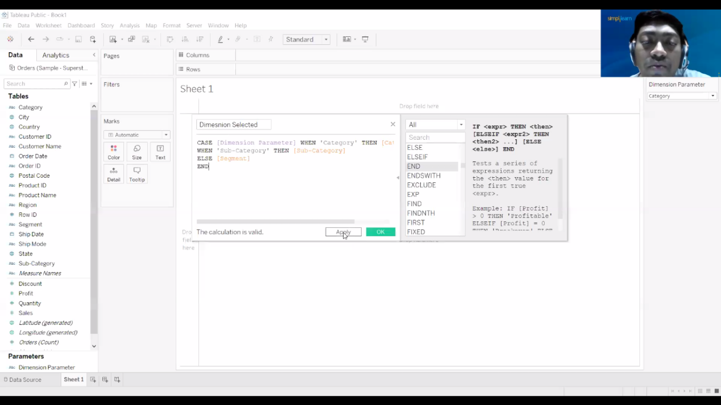

Case [Dimension Parameter] When ‘Category’ Then [Category] When ‘Sub-Category’ Then [Sub-category] ELSE [Segment] END

Q.-Using the parameter find the category , sub-category , segment sales:

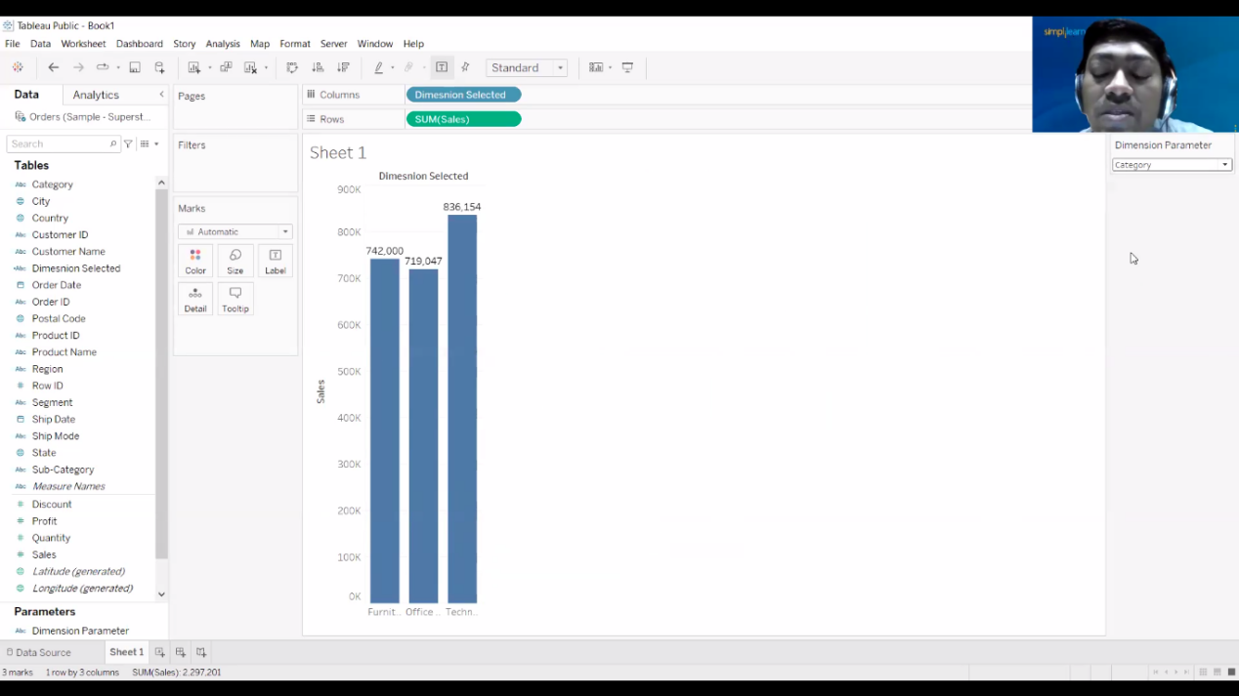

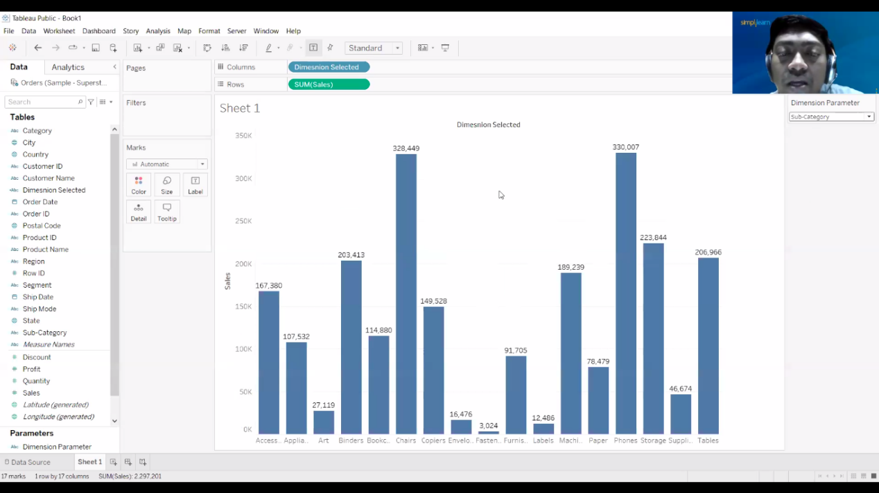

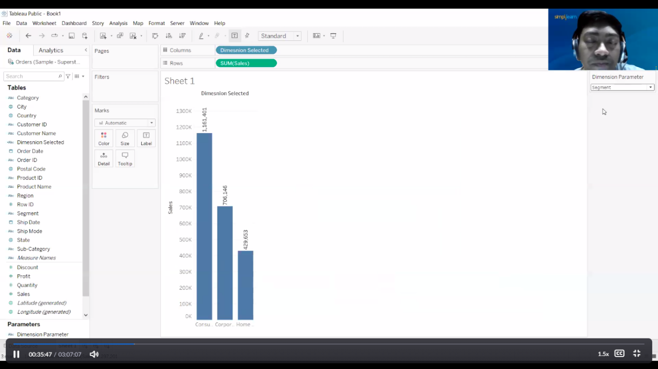

Create the Measure Parameter:

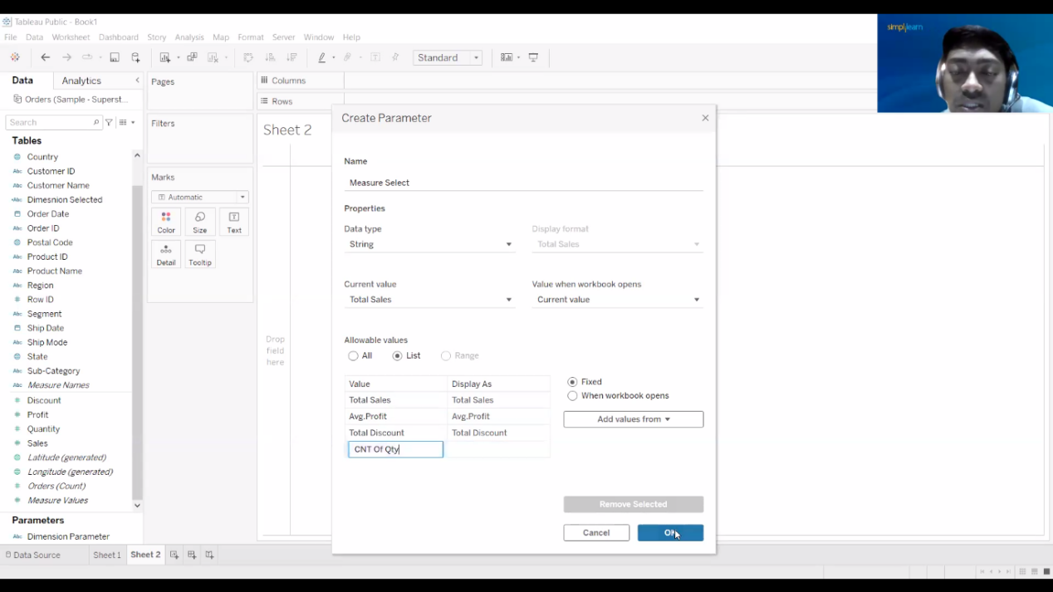

Create calculated fields for the measure parameters:

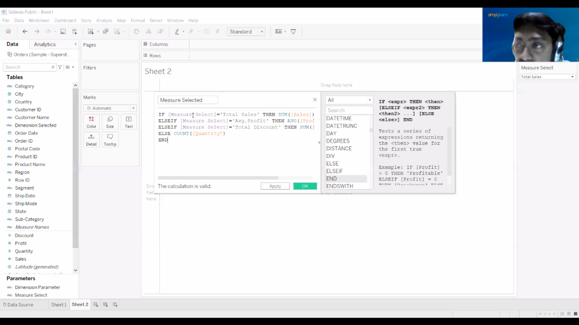

If [Measure Select]=’Total Sales’ Then SUM([Sales])

ELSEIF [Measure Select]= ‘Avg. Profit’ THEN AVG([Profit])

ELSEIF [Measure Select]=’Total Discount’ THEN SUM([Discount])

ELSE COUNT([Quantity])

END

Find the category sales:

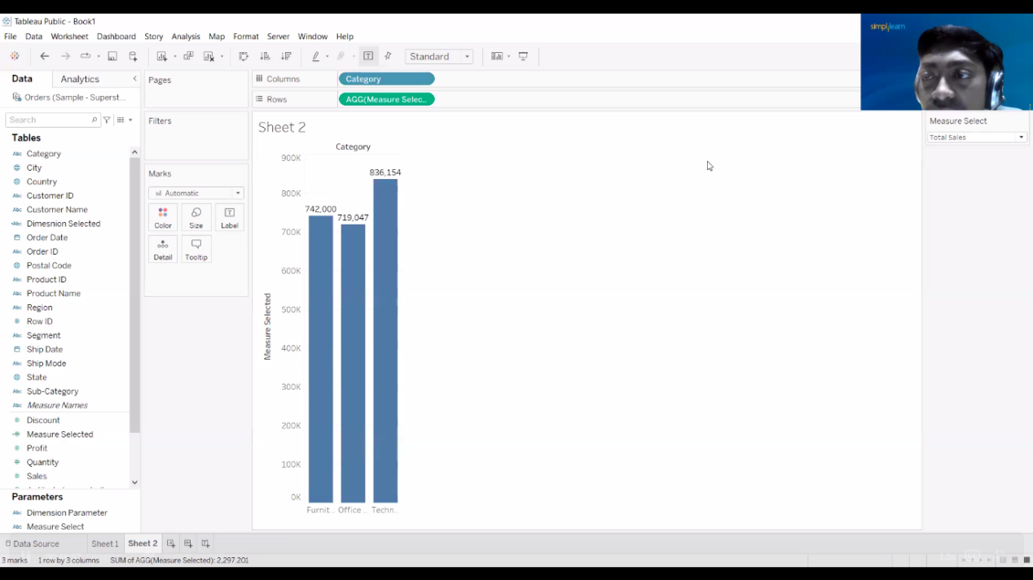

Find the category average Profit

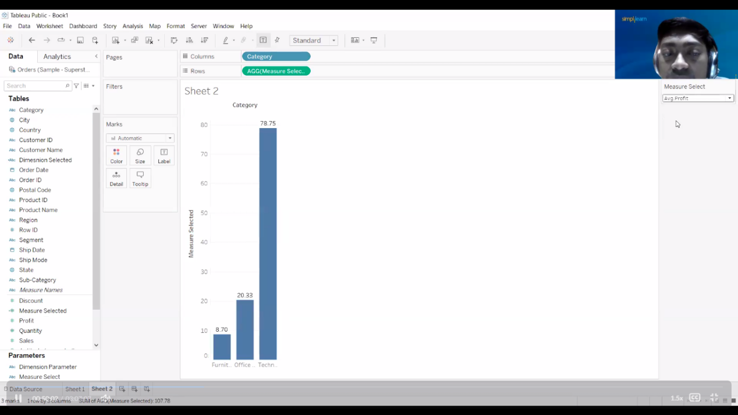

Find Count of quantity

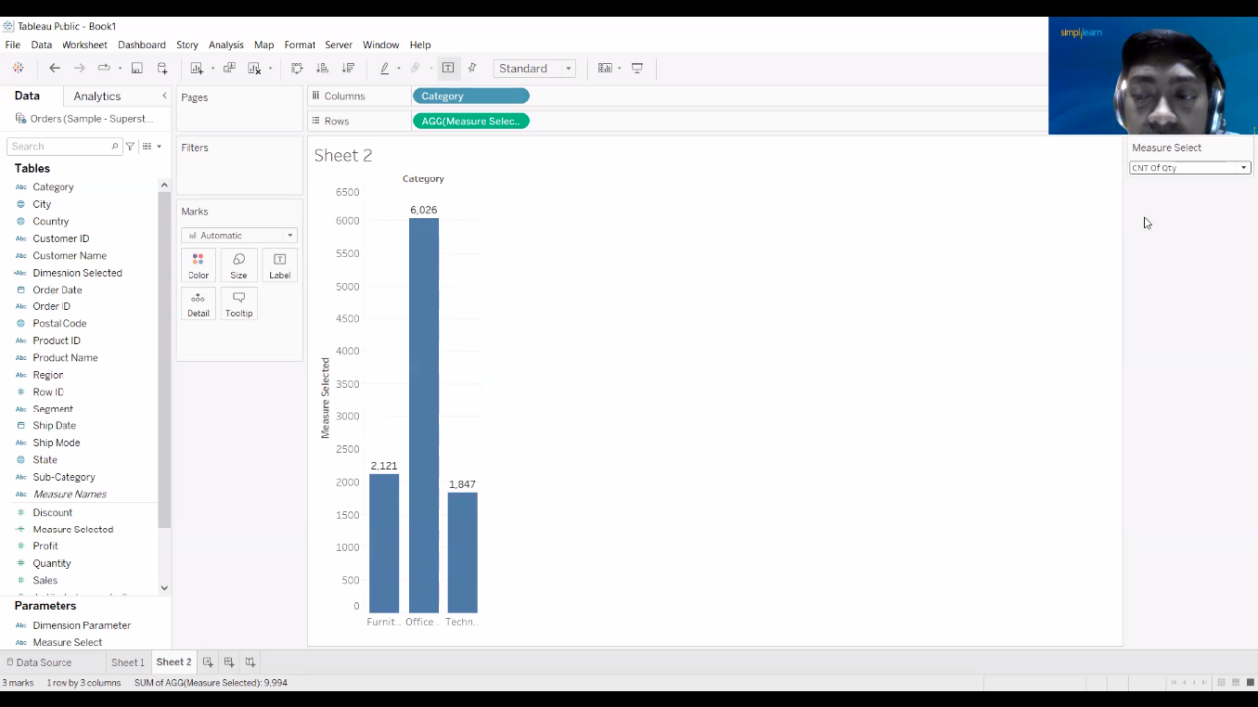

Create the Date parameter

Start Date

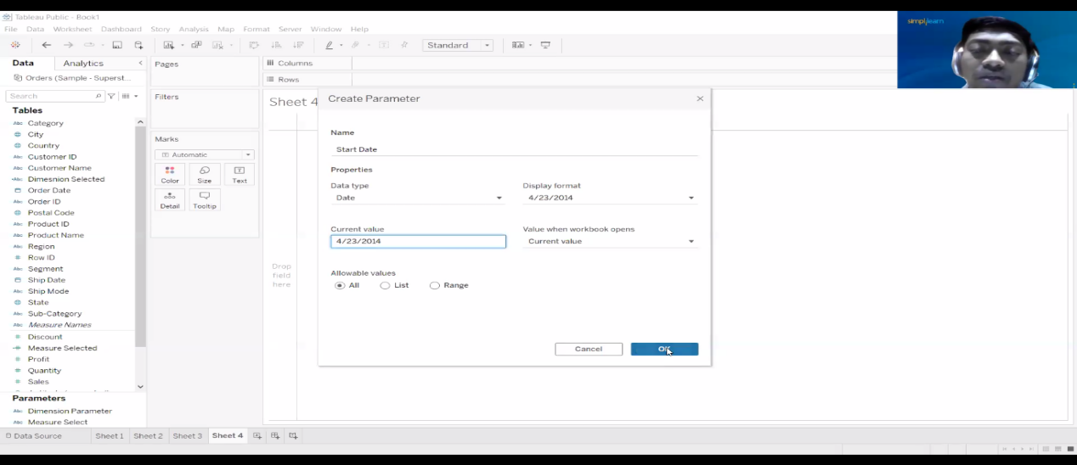

End date

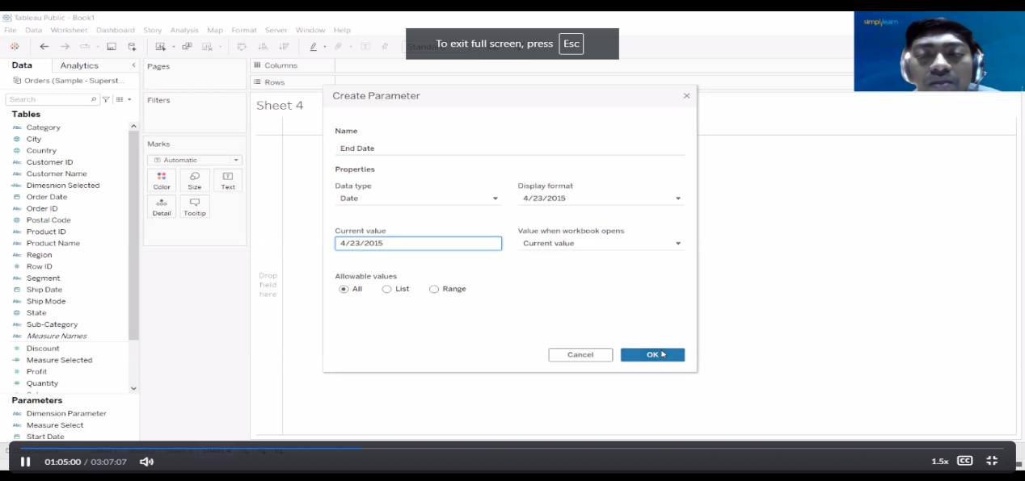

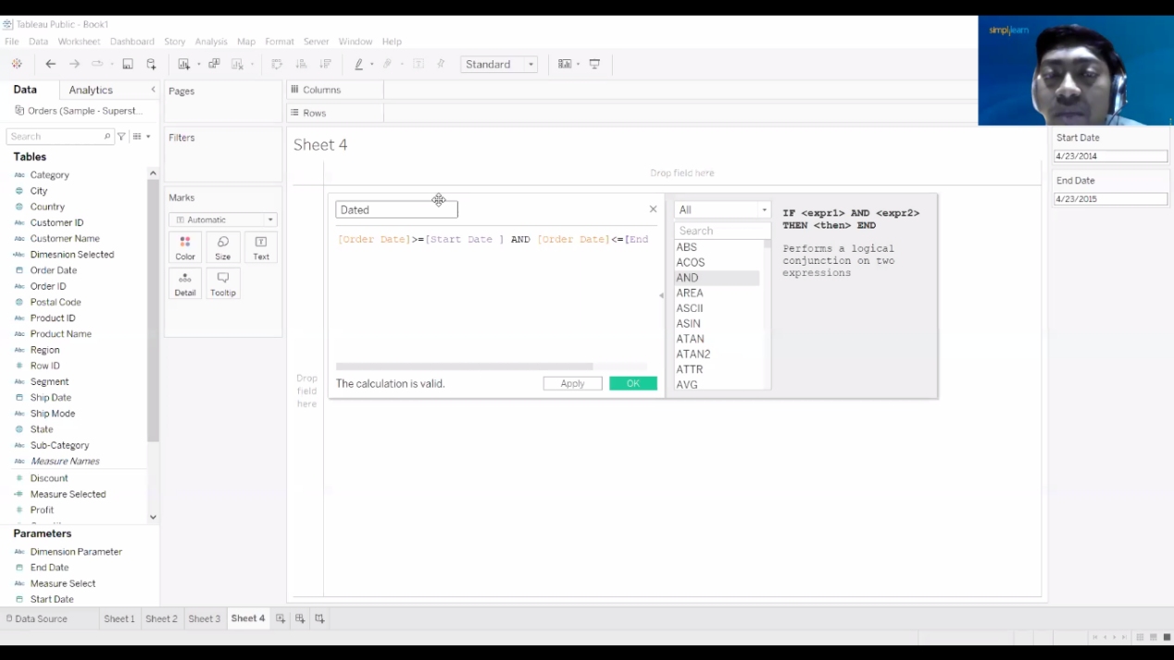

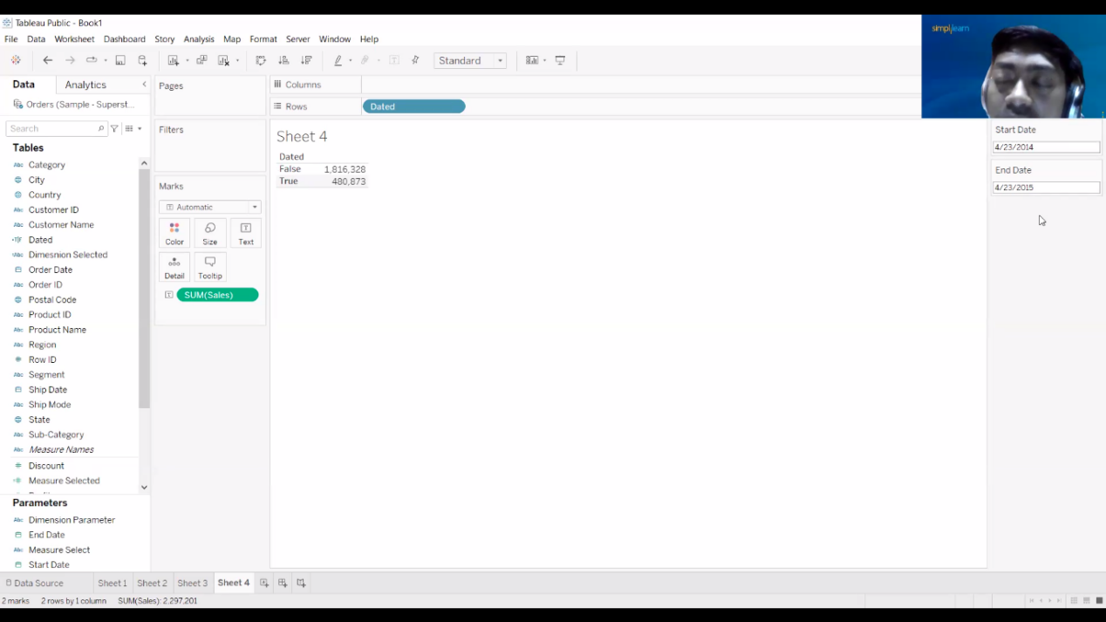

True refers to the event occuring and False for the event not occuring

Tableau Dashboards and Story Creation: Create Dashboards, Actions in Dashboard, Dashboard Objects, Create Story

Week 10: Create Dashboard

The main use of a dashboard is to show a comprehensive overview of data from different sources. Dashboards are useful for monitoring, measuring, and analyzing relevant data in key areas.

Q1. Create dashboard for the following

1. Create country state sales map selector
2. Create monthly sales timeline
3. Find the top 5 city sales

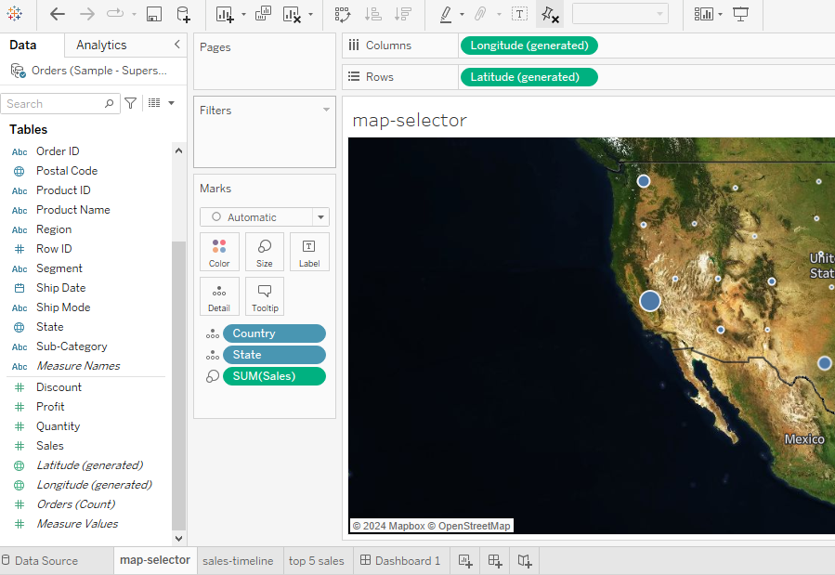

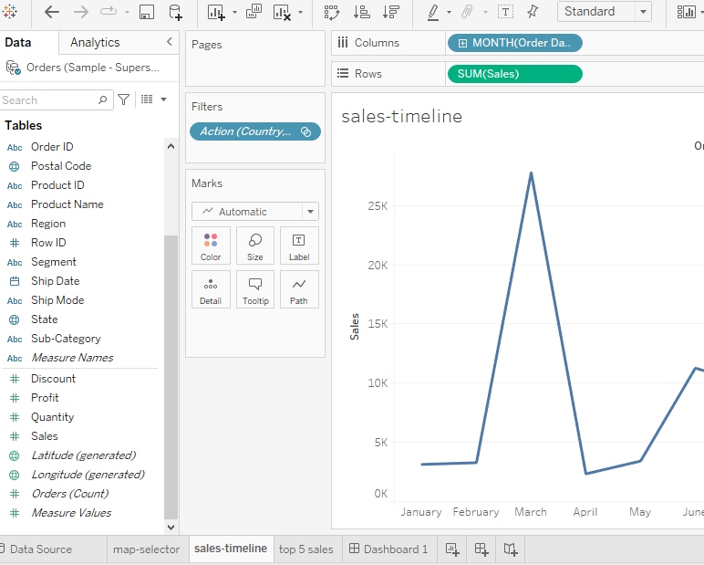

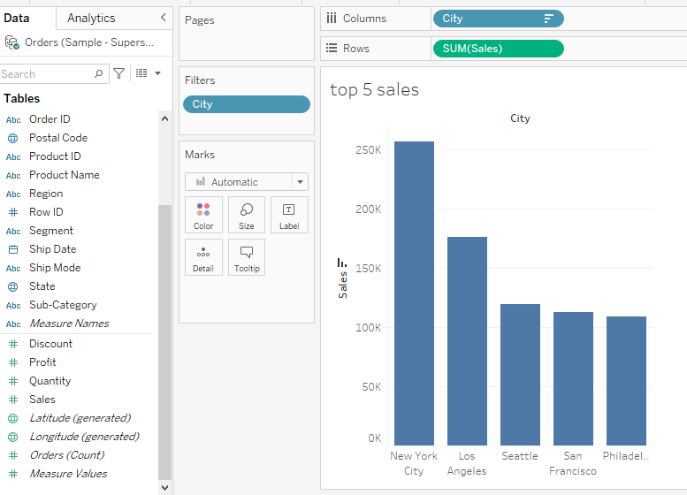

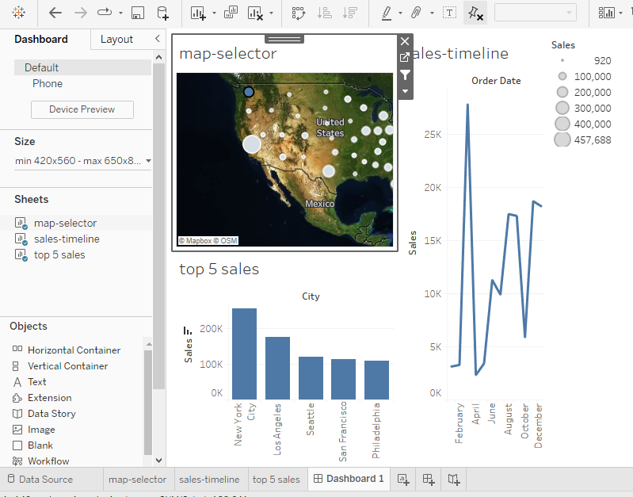

Filters:

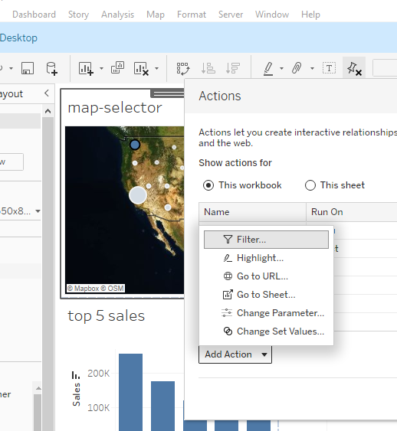 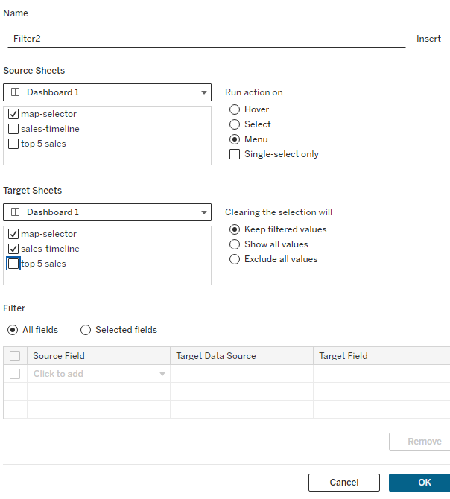

Q2. create the dashboard for

1. Category wise sales
2. Category, sub-category profit
3. Year month-wise sales
4. Country state profit

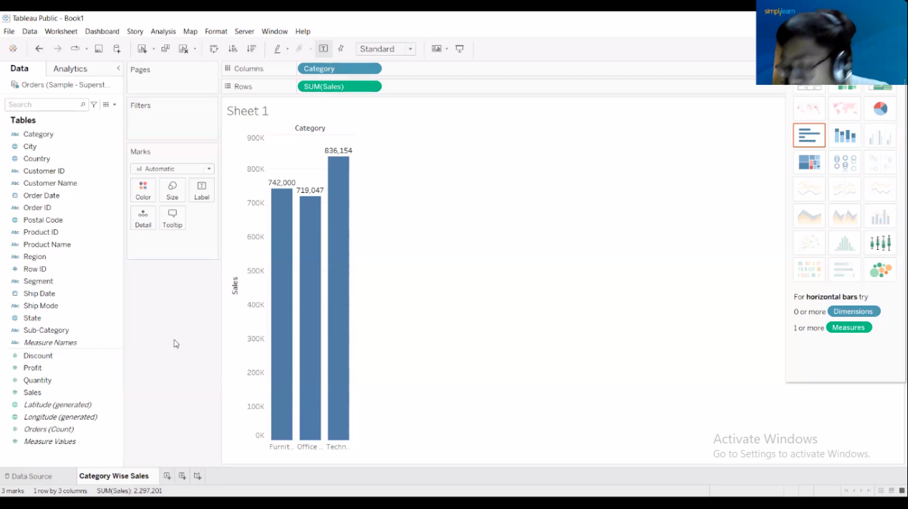

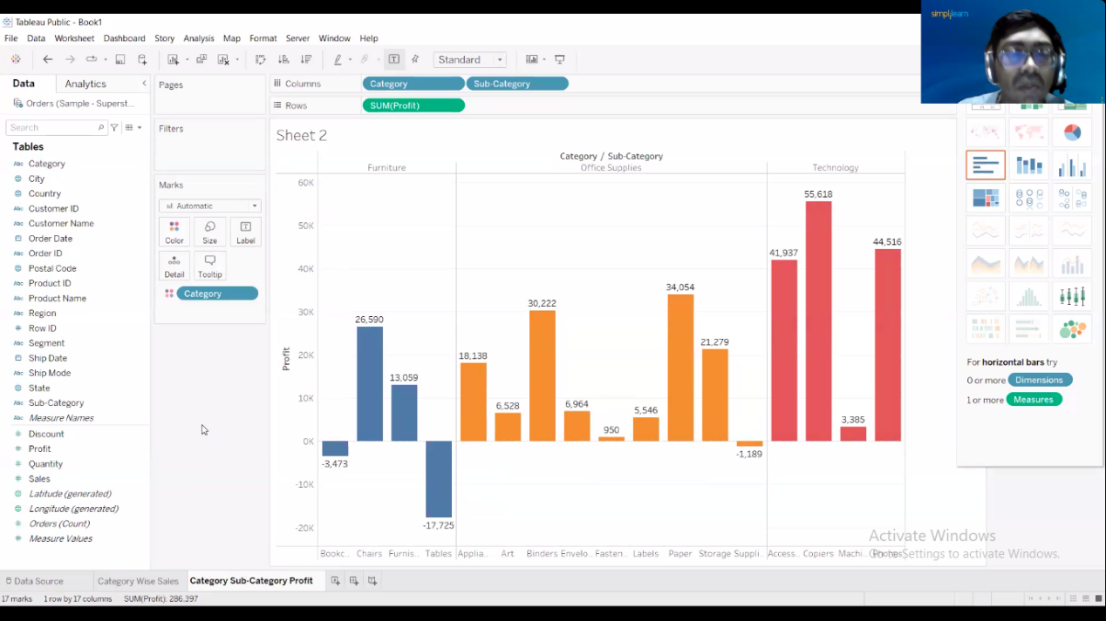

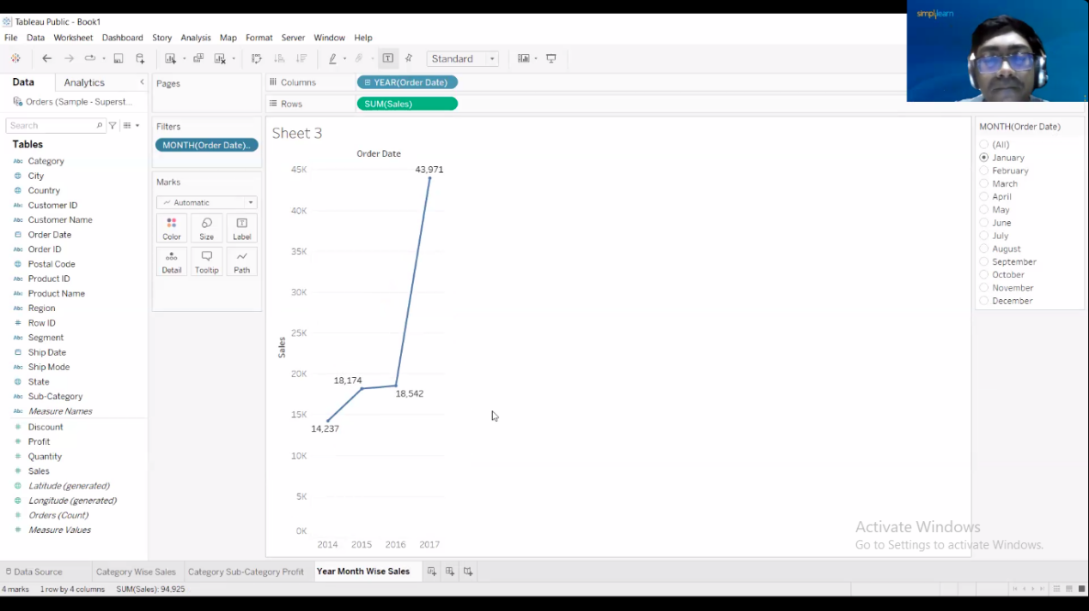

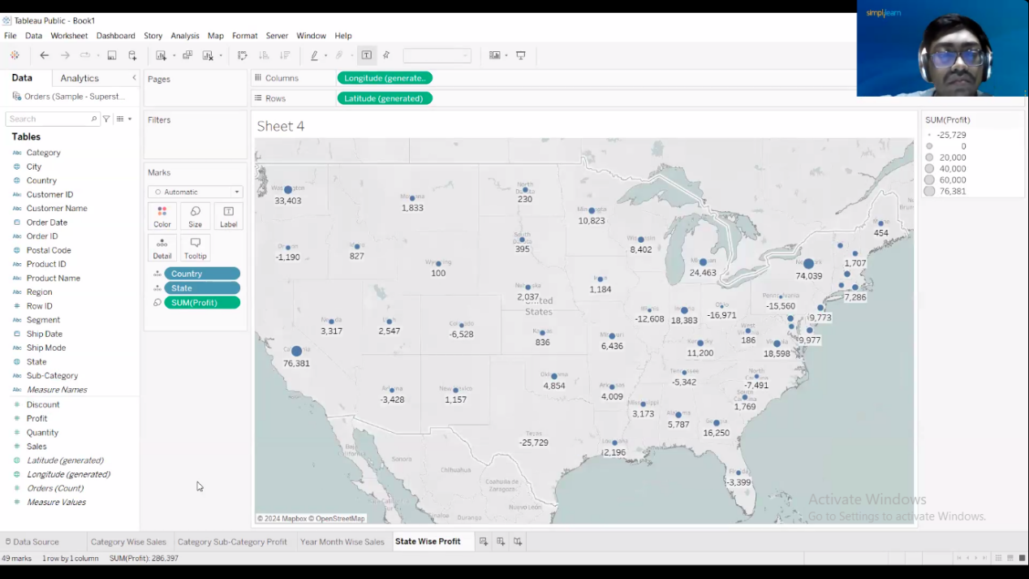

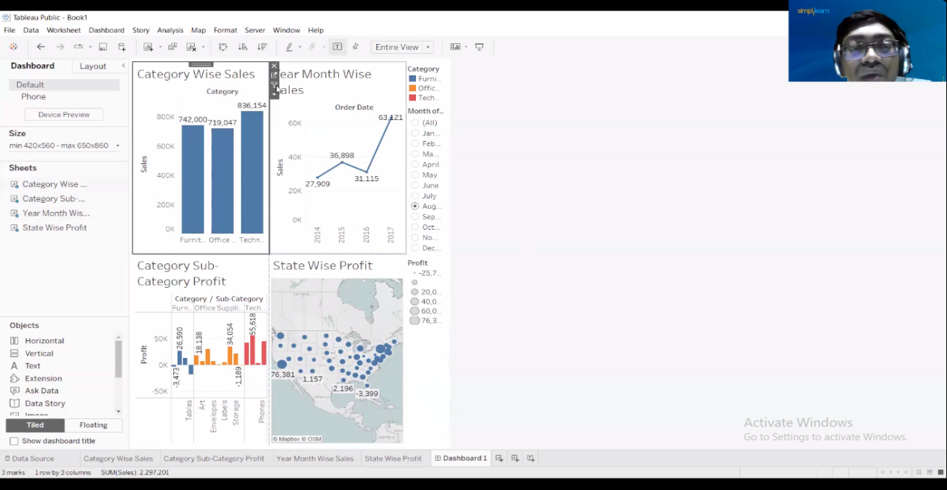

Add filters:

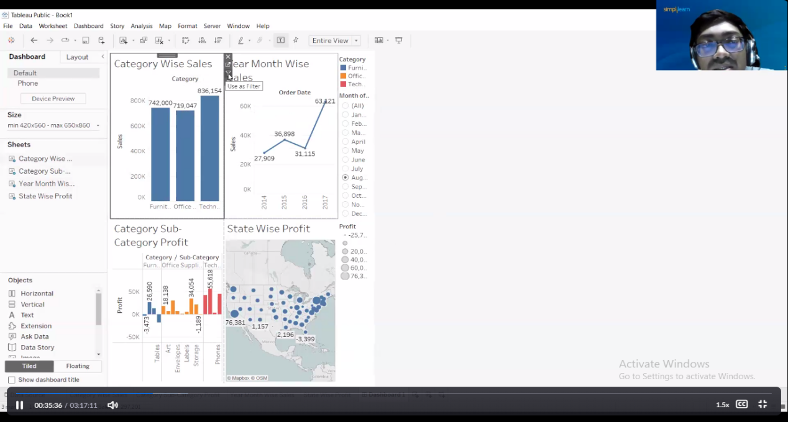

Add the web page link using object:

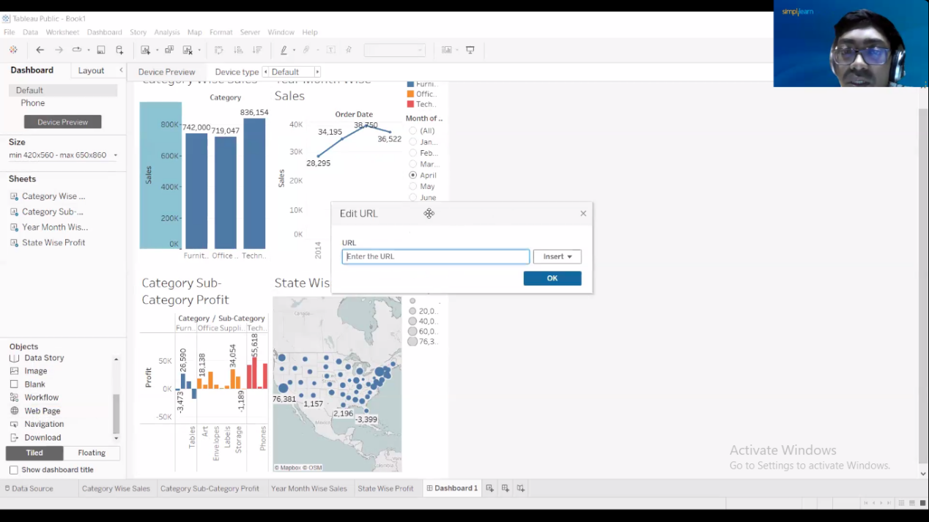

Q 3. create the story for the above created dashboard

